How to do a Backup in 3.0
To do a backup in 3.0 just follow these steps:
First, Close out of the company list.
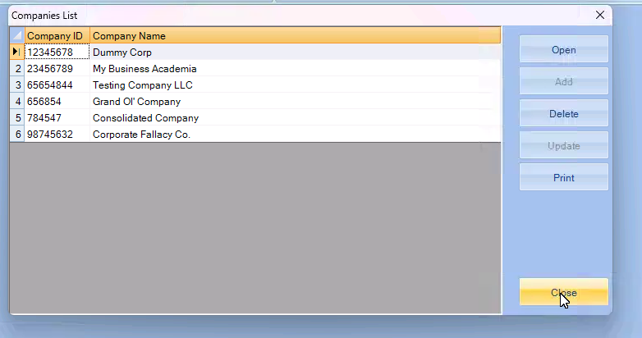
Navigate to the Tools tab.
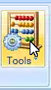
Click on “Backup Company”
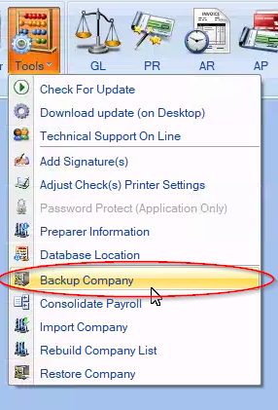
Which should open into this box (seen below)
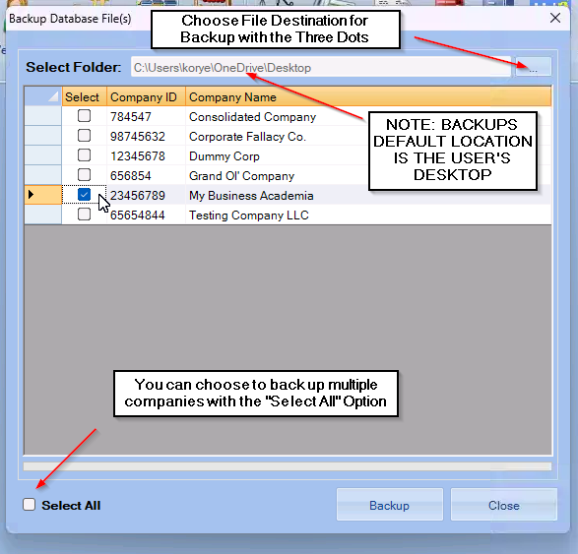
After selecting your company (or companies) You’ll click the Backup Button. Once the back up is created, the box will close. Navigate to your desktop to locate the backup file.
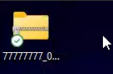
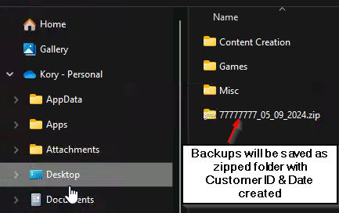
To restore the company, you’ll go to the bottom of the tools tab

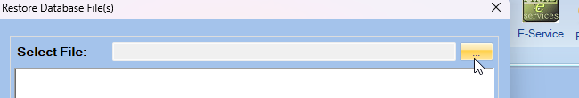
Click on the 3 dots to choose the file location.
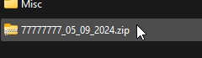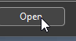
Select the company or companies that you wish to restore, then click the button.
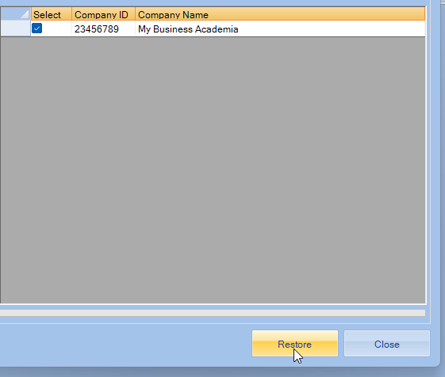
Once the restoration is complete the Restore Companies box will close itself.

