How to Change Permissions For AME 3.0
If you are experiencing issues with the AME program not having the specific permissions needed, this guide will walk you through a solution to these issues.
FIRST: CLOSE THE PROGRAM BEFORE STARTING THE STEPS IN THIS GUIDE
To change the permissions for your AME application just follow these steps:

RIGHT CLICK on the icon to pop up the drop-down menu and click on properties:
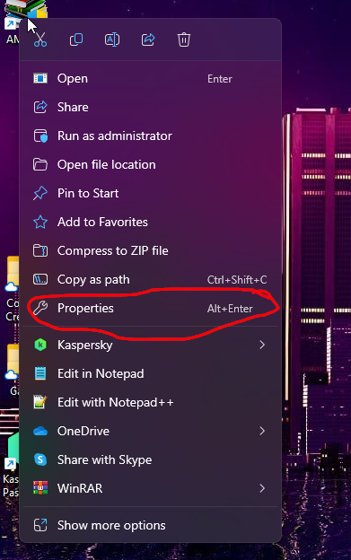
In the properties, the first tab that you’ll go to is the “Compatibility tab”
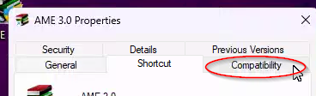
Click on “Change settings for all users”
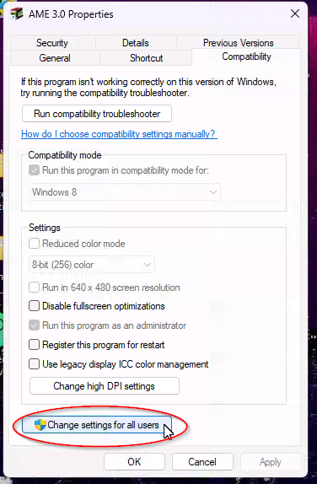
Check the box for “Run this program as an Administrator”
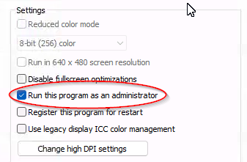

After finishing up with the Compatibility tab, You’ll navigate to the Security Tab.
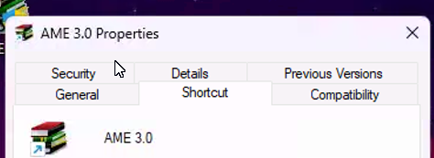
Under the security tab you’ll see a list of users.
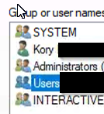
With a list of permissions below it.
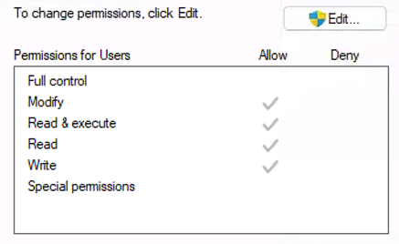
Click Edit to change the permissions for the users.
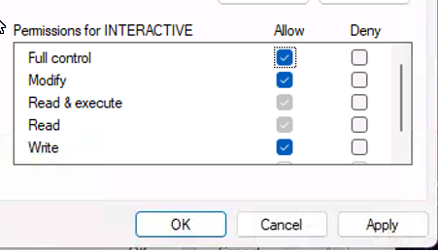
Click on the user that needs access to the program and then click “Full Control” and click “Apply.” After clicking apply, you’ll click “OK” to close the box. After that, close out of the properties for the AME 3.0 and try opening the program again.
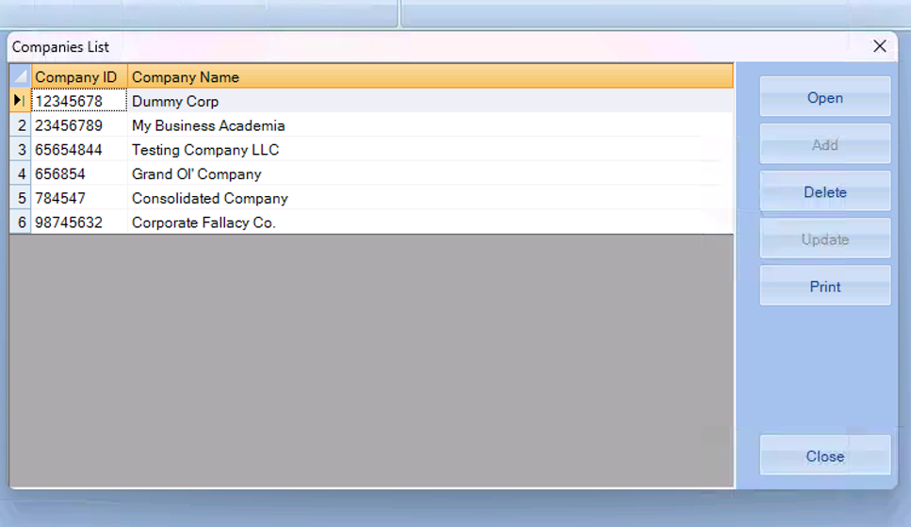
And you should be good to go!

FOR DOMAIN USERS WITH RESTRICTED NETWORKS:
Here is a link to a guide that I have found to be useful in a scenario with users who CANNOT have full admin access on their account.
https://community.spiceworks.com/t/deploying-a-whitelist-software-restriction-policy-to-prevent-cryptolocker-and-more/1008381

IF you are still having difficulty or needs help please call 1-800-263-9455 for further support.

