Tools Tab Walkthrough
Now that we have our Bank, Company, & Employees setup…. Let’s explore the program a little further and get into the Tools tab.
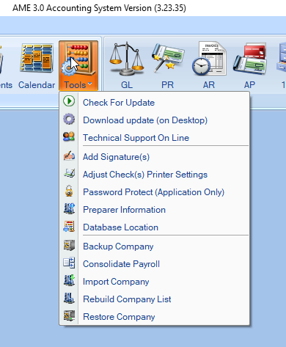
“Check For Update” will see if the latest patch has been downloaded and the program is up to date.

If you are experiencing an issue with the program, call 1-800-263-9455 to get in touch with a technician.
With the technician on the phone, you’ll click on “Technical Support Online”
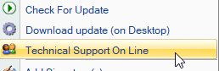
After clicking, a box will open with a six-digit code. The technician will use it to connect to your computer to troubleshoot.
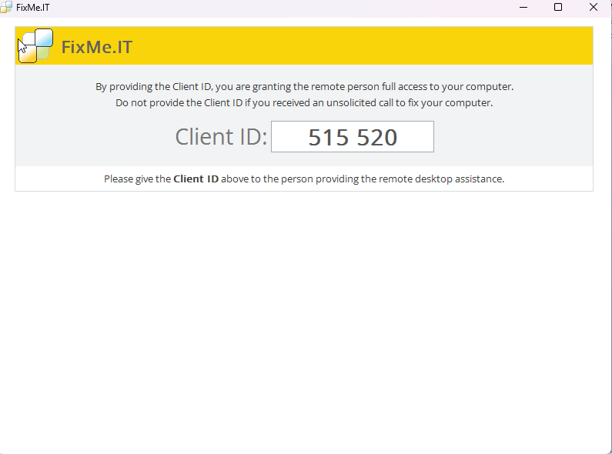

The “Add Signature” function will allow you load a digital copy of your signature to post on checks:
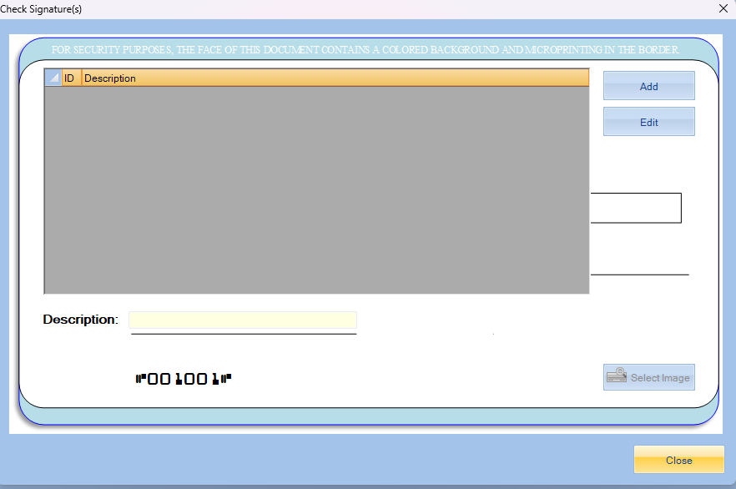
After clicking the “Add” button, the “Select Image” button will become active.
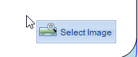
You will use the select image button to navigate through your files to find the signature you want to add.
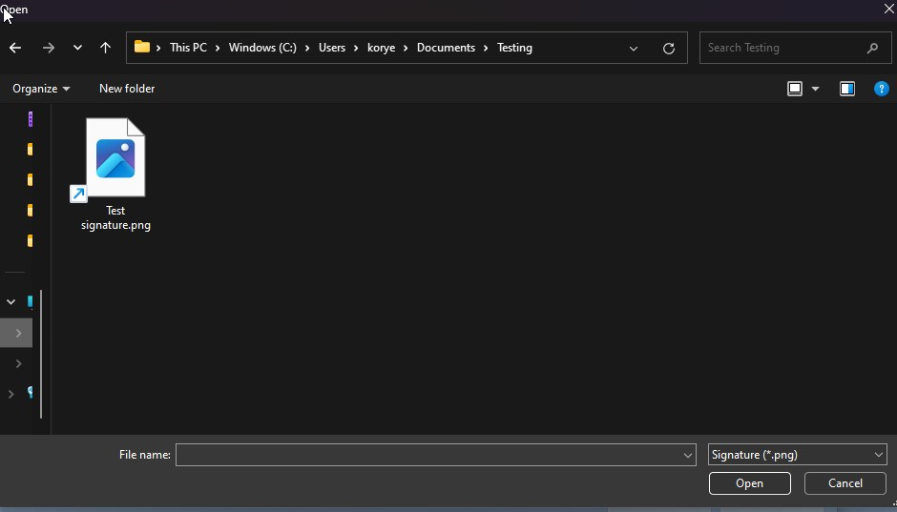

After selecting the signature file that you want, you’ll click open and you can see a preview of how it will appear on the checks
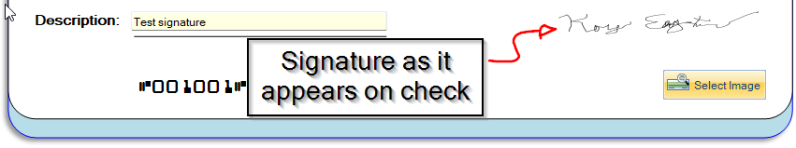

Once the signature file is loaded, click okay, and your signature is now available!
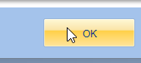

The next area in the Tools tab is the “Adjust Check(s) Printer Settings” section, which will change the placement of text and setup of checks and reports.

The next area is the Password Protection
Here, you’ll be able to set a password for entry into the application.

