Error Code Q & A
THE FIRST STEP TO TAKE IN ANY TROUBLESHOOTING SITUATION:

ENSURE THAT YOUR PROGRAM IS UP TO DATE. Check www.amesoftware.com/support to make sure that you have the most current version of the AME software.
In this document we’ll go through some of the common error codes that you might encounter when trying to import your clients from 2.0 to 3.0 and other general questions that are commonly encountered.
Q:I don’t see an add or delete button for check information or tax deposits?
A: SOLUTION: Anywhere that you do not see an add or delete button try a RIGHT CLICK and you should have a drop-down menu appear that will give you the option to add or delete

Q: I keep getting this pop up when trying to make a check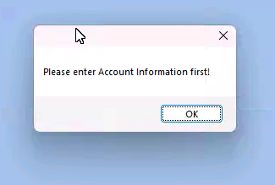

A: There is no bank set up or the saved bank does NOT have an account number set. Fill in the bank information and then save it. Close the program and re-open to refresh it. When the bank information is saved properly that pop up will stop coming up.

Q: Operator “DB-null” “ ” error
A: An employee is missing an SSN,
- You can either enter the SSN or use “000-00-0000” and then the checks should be able to print.
- Q: I can’t save a tax deposit! I typed in the Payee name and it won’t go through!
- A: SOLUTION:
- -Go to “Tax Deposit Payee Information” in your Payroll “Setup/Activities” add the name of whomever you will be making the deposit out to,
- -Go back to the Tax Deposit, choose the “Payee” from the drop-down menu, and then it should save correctly.
- Q: Where do I delete/void checks?
- A: SOLUTION:
- -In the list entry section, go to your “List entries” type in the date range for the check that needs to be deleted.
- -Select the check in question, RIGHT CLICK on the entry and a drop-down menu will present with the options to either: Edit, Delete (Select Entry), Delete ALL entries, Void
- -SIDE NOTE: The little check box under the area that says “VOID” is a confirmation of whether the check has been voided. IF the check HAS been voided… There will be a check in that box. If the check has NOT been voided, the box will be empty.

Q: Operator = “DB-null”… “Date” When trying to print checks?
A: SOLUTION: An employee is missing a hire date and the setup option “Use hire date for calculation of Sick/Vac. Time” is checked
- Go to Setup & Activities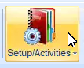
- Go to “Payroll Setup Options” in the drop down menu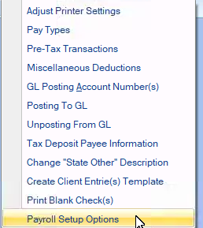
- UNCHECK the option”Use date of Hire for calculation…”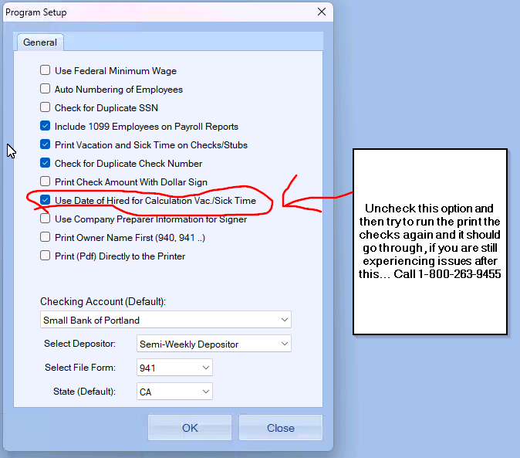
Then you should be able to print the checks

Q: Error Column 31: Employee information is not found, needs to be refreshed
A: SOLUTION:
-Go to the 2.0 program, open the company in question.
-Open the employee list
-Open ONE employee
-Close the 2.0 program and try to reimport and it should go through
Q: Error Column 25: Missing information in some area/ no employee in payroll
A: SOLUTION: Fill in any areas that are missing information and try to re-import. And it should go through.
ALTERNATE SOLUTION FOR 1099 ONLY:
-FOR 1099 ONLY CLIENTS:
CLICK THE COMPANY AND THEN CLICK OKAY. DO NOT MARK PAYROLL IF THEY ARE 1099 VENDOR CLIENT ONLY.

Q: “HRxRESULTxxxx….. cannot find… While Printing”
A: SOLUTION:
Adobe is not set as default PDF reader,
Go to your setting and look for:
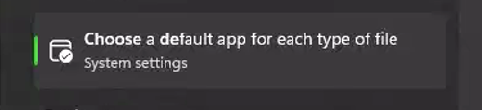
For PDF files, choose adobe, and this should fix the issue.

Q: My settings are right, but my checks aren’t showing up?
A: SOLUTION:
Adobe is opening in the background. Hit Ctrl+Alt+Del on your keyboard to pull up task manager,
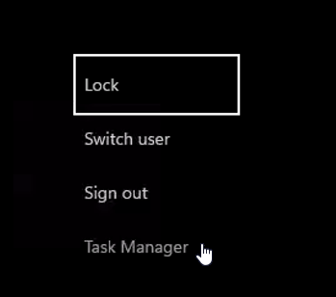
Look through the “Background processes” and close any instances of Adobe.
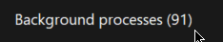
Right Click on the instance and it will give you the option to end the task.
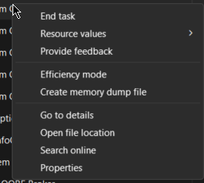
Close out of AME 3.0 and then re-open and try to print the check, it should go through this time.

