Direct Deposit & ACH File Walkthrough
When going through the process of creating an ACH file to be submitted to Kota Pay, American EFT, etc., follow these steps to locate the file for submission.
- Make sure that you have the direct deposit information filled out for the employees.
- Go to your Employee tab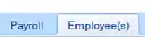
- Click on “Employee info” to pull up your employee list (seen below)
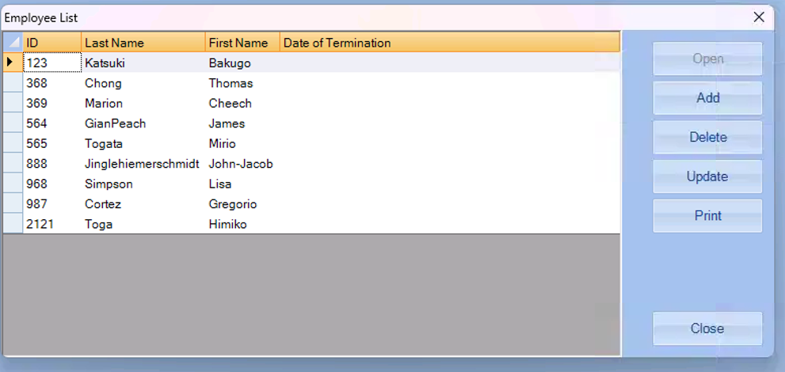
- Click On the employee and then Click update (OR Double Click on the employee) to edit or update the employee information
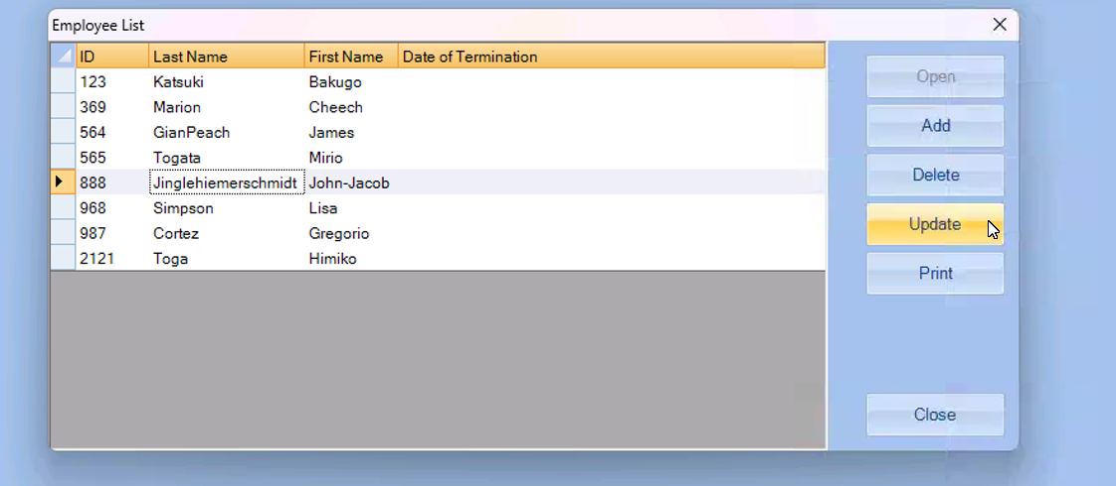

- Which will open into the “Edit Employee Information box”, click on the last tab for “Direct Deposit” (Seen below)
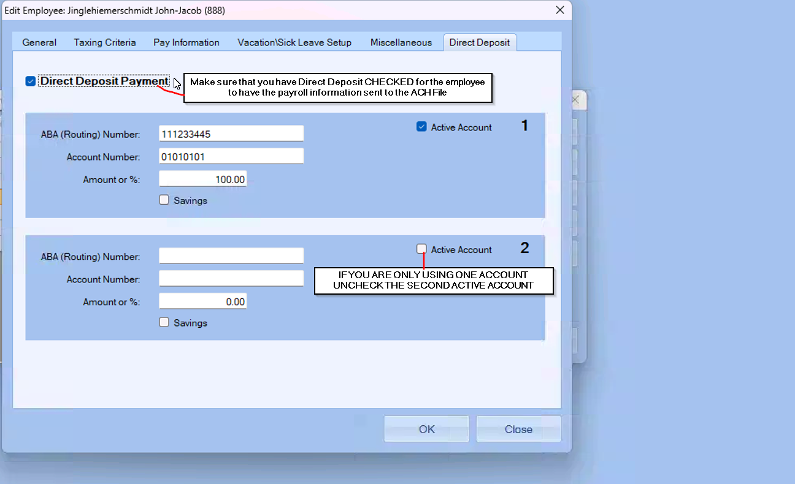
Once your Direct Deposit information is set up for the employees that you need, we can move on to creating the ACH File.
After you’ve entered in your check information
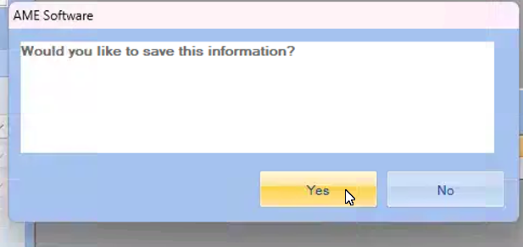

Go to the Direct Deposit tab
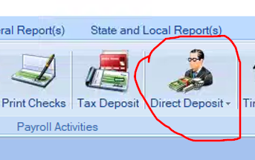
Click on “Make ACH File” and choose the Check Date for the ACH information
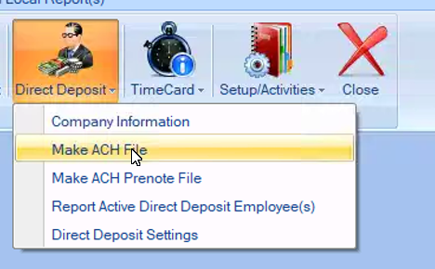
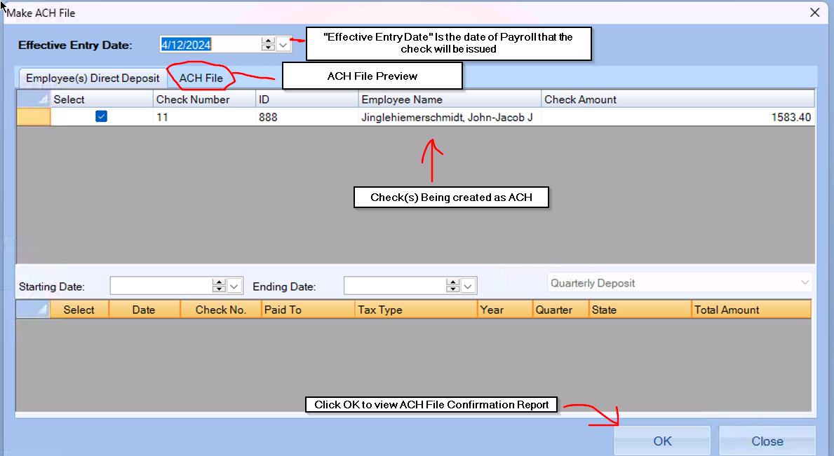
- The checks that are ready to be created as an ACH File will show up in the box (seen above)

- Click OK for a Direct Deposit Report record which will show where the ACH File is located and the title of the document.
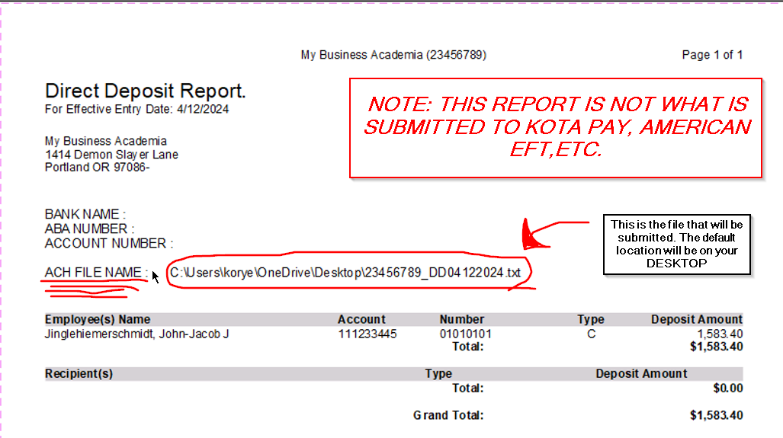
- Go to your desktop to locate the ACH File
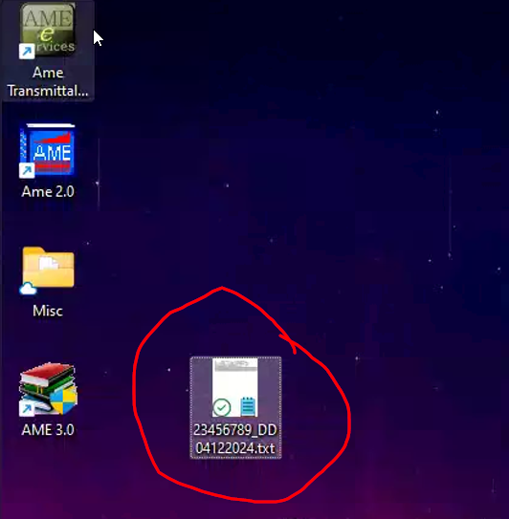

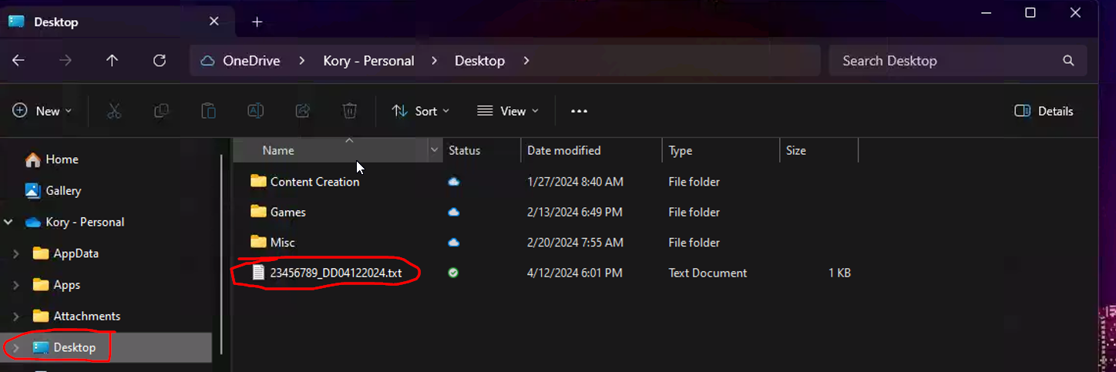
- Log in to your Direct Deposit Distributer site (Kota Pay, etc.) and submit the TXT file.
- And that’s Direct Deposit from start to finish!
- If you have any issues with your Direct Deposit please call 1-800-263-9455 for further support.

