Printing issues in 3.0
If you come across this issue.
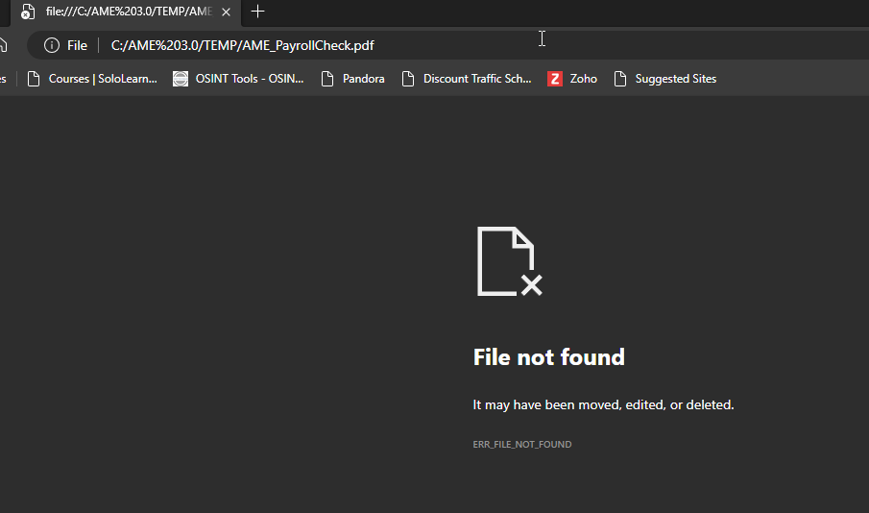
Click on your start menu and start to type “Choose a
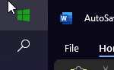
Select “Choose a default app by file type”
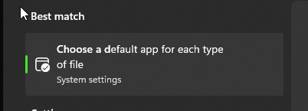
And you’ll open into this box
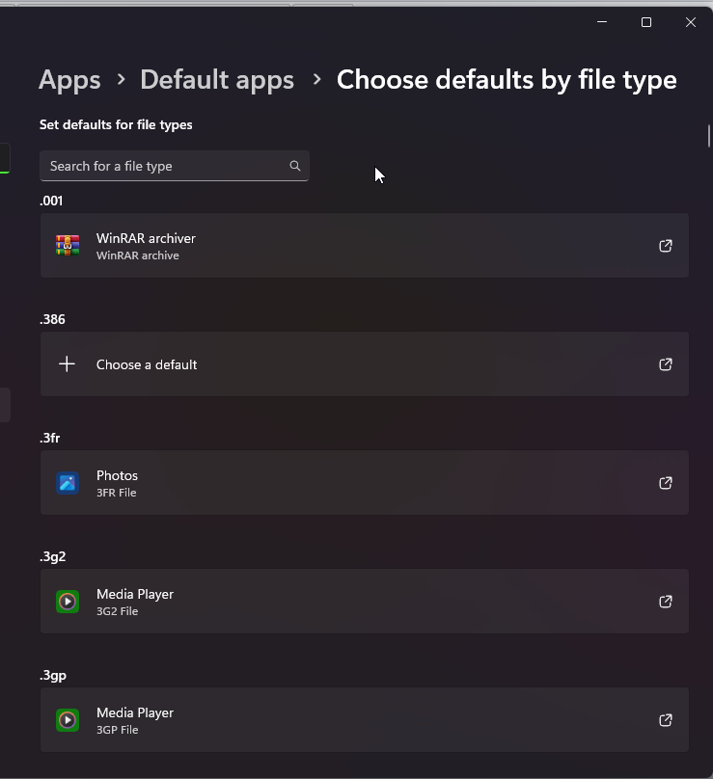
Scroll down until you find “pdf” and click on it
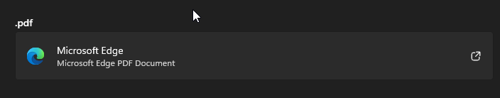
Which will open up a list of options, where you can choose “Adobe Acrobat” as the default PDF reader
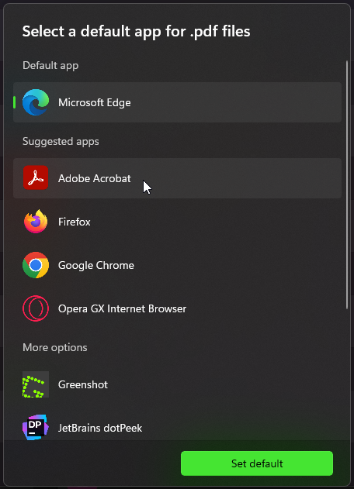
After choosing adobe for your default PDF, go back and try to print the checks again,

IF YOU ARE STIL EXPERIENCING ISSUES AFTER FOLLOWING THE GUIDE PLEASE CALL 1-800-263-9455 FOR SUPPORT

