Tax Deposit Walkthrough
NOTE: ALL TAX DEPOSITS REQUIRE A PAYEE CHOSEN FROM DROP DOWN MENU!!!! CANNOT TYPE IN PAY TO NAME!!
Setting up a Tax Deposit Payee:
On the Payroll screen, Click on Setup/Activities, in the drop down menu, Click on “Tax Deposit Payee Information”
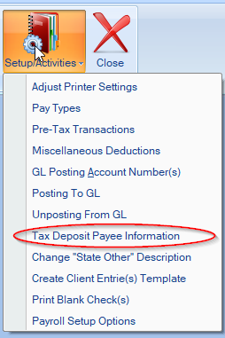
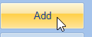
Click “Add” to add a new tax deposit payee. And you’ll fill in the necessary information.
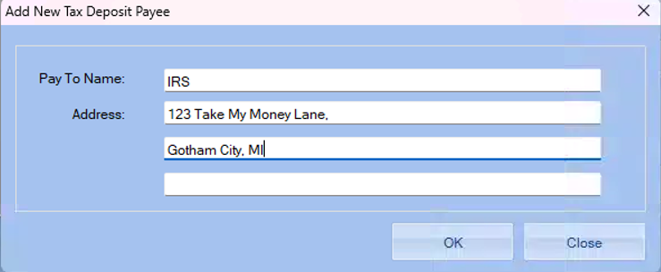
Click OK to finish, and now that Tax Payee has been successfully added
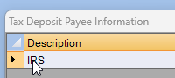
Now We’ll move on to creating a Tax Deposit:
Choose the company that you are working with
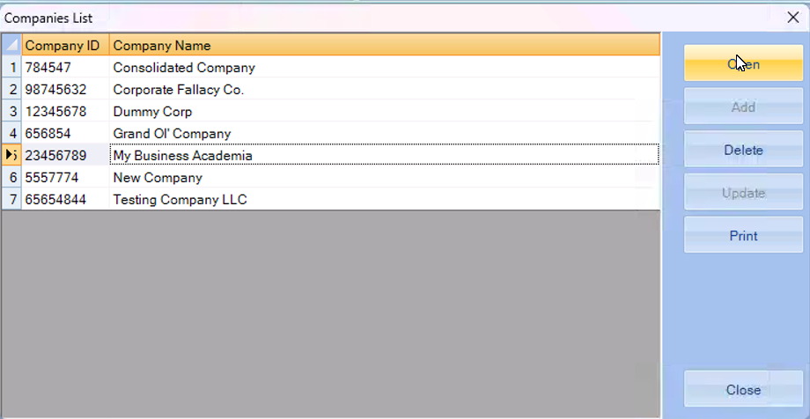
Click on the PayRoll Module
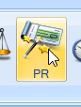
Then once the payroll window opens, click on “Tax Deposit”
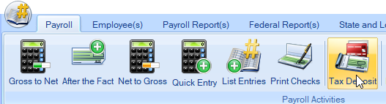
And you’ll open this box
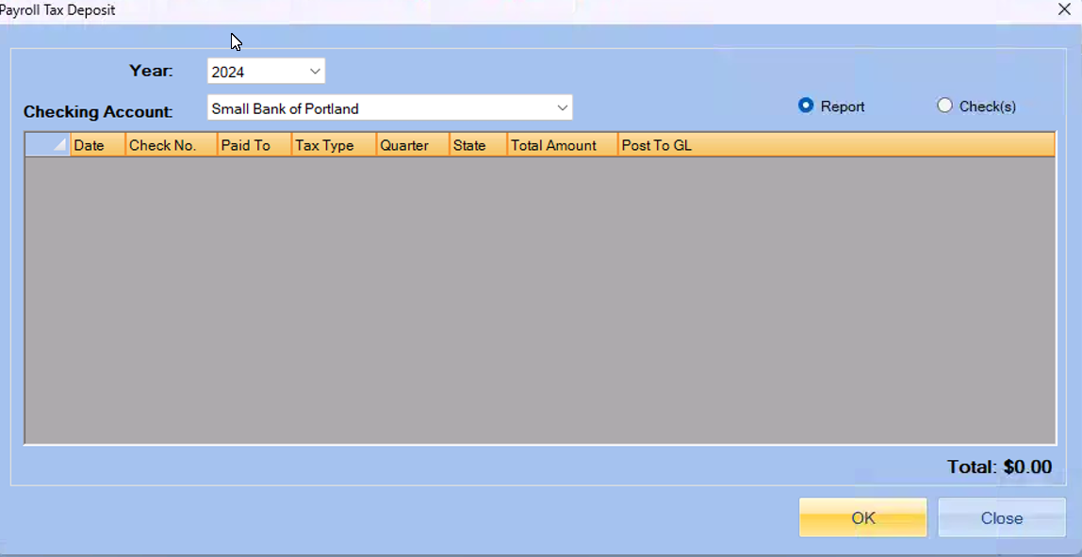
In the grey box, RIGHT CLICK to add a new deposit
Which will open this box
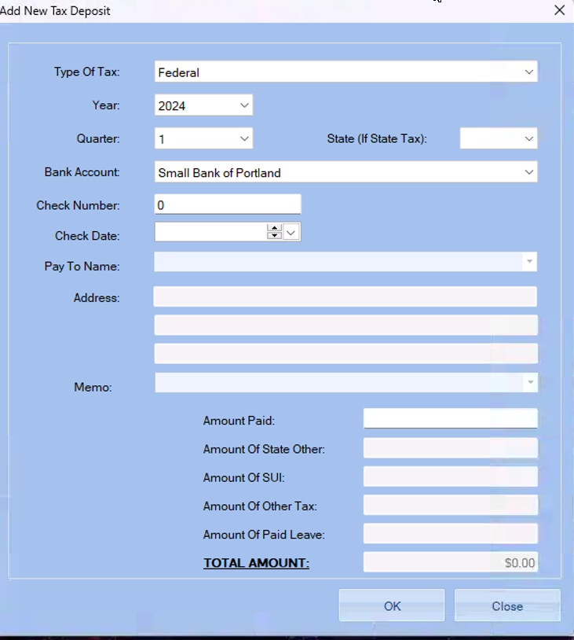
In the drop down menus you will be able to chose the type of tax, fiscal quarter and the year and the state.
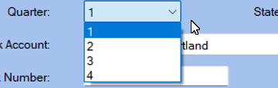
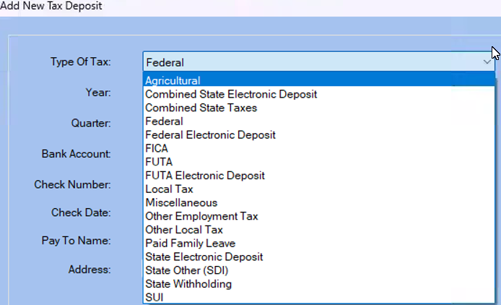
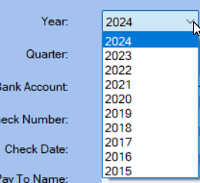
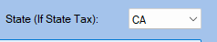

Next, you will be able to set the bank, check number, and check date.
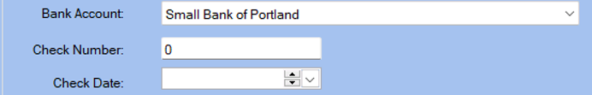
The next area will be the Tax Deposit Payee or “Pay to Name.”

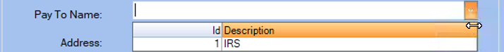
After adding your Tax Payee they will appear on the drop down menu in “Pay to Name”.
In the next section you will have the address, a memo for any notes you need to make and amounts.
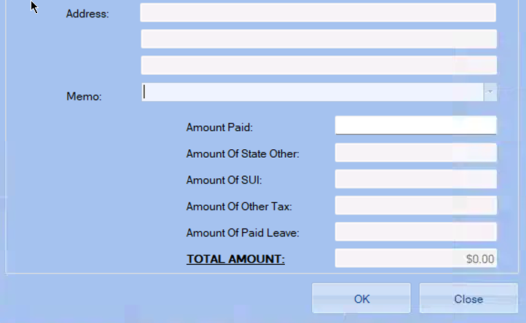
After filling out the necessary information, click OK and you will be asked if you want to save the information.
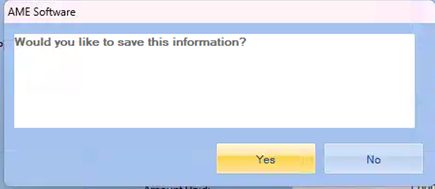
Click yes, and you’ve successfully created your tax deposit!
