Update Walkthrough
If you need to update your software, just follow these steps:
- Go to www.amesoftware.com
- Click on the “Support” Tab
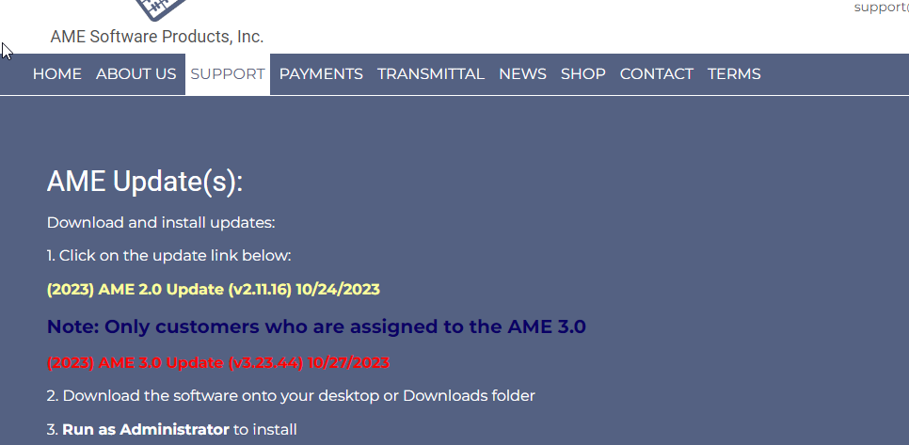
Click on the update
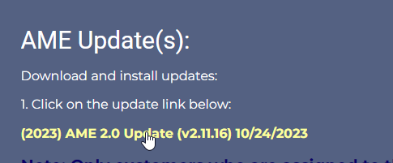
You’ll see the update appear in your recent downloads folder up in the top right hand corner.
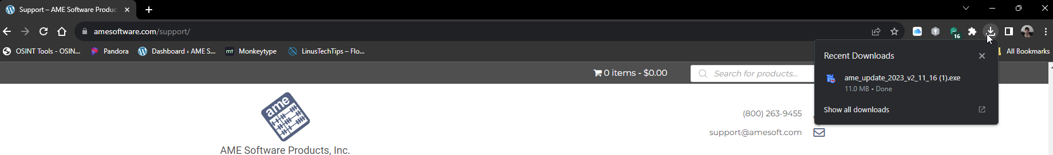
Double click on the install file to run the installer
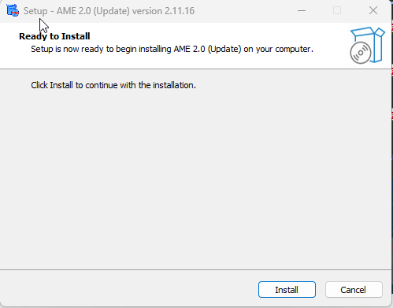
(NOTE: Please make sure the program is closed BEFORE updating)
Click Install to run the update. Once completed you will get a confirmation of the update
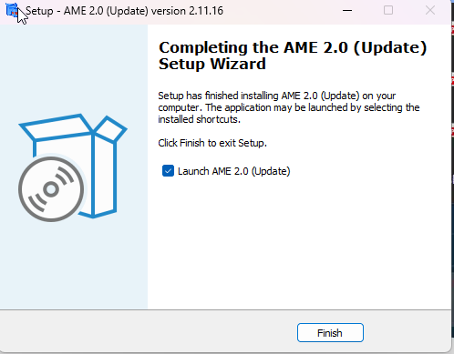
And now your 2.0 program is up to date!
Now We’ll update the 3.0 app
Go to www.amesoftware.com/support
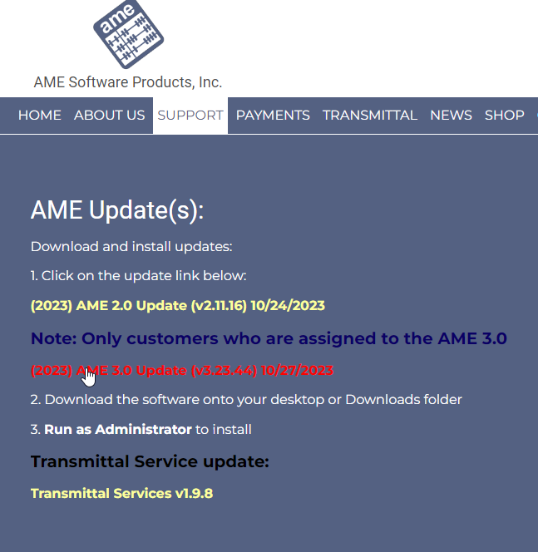
Click on the 3.0 update, which will appear in the top right corner
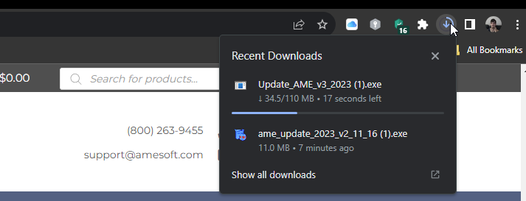
Double click the installer to run the update, Then click “Install” to run the update
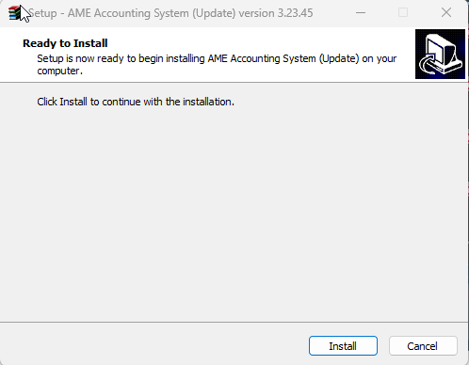
After the installation is complete you’ll get a confirmation of the update
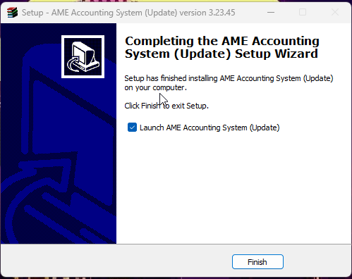
Now your program is completely up to date!

