Setting up AME Config File

After registering and installing the product one of the last steps in set up is to set up the PDF reader for AME.
First we’ll use the File Explorer. Click on the folder icon.
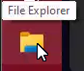
Which should make this box appear
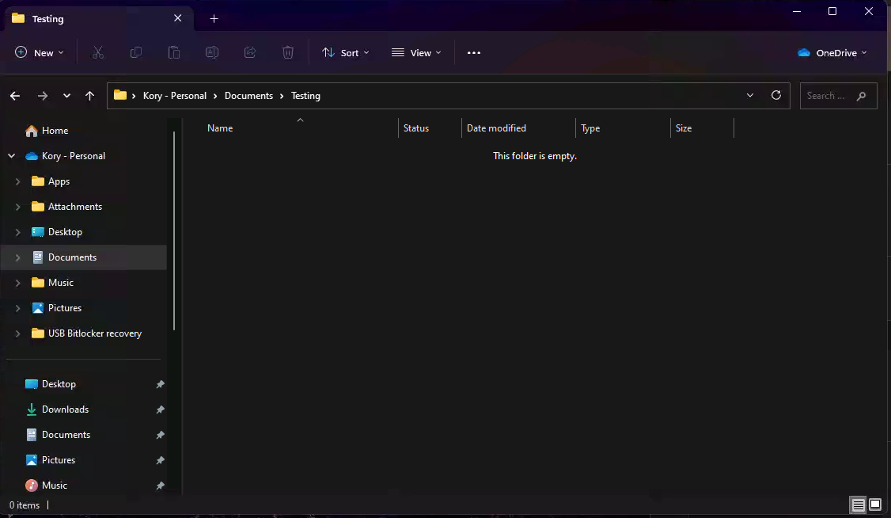
Once we have this box open, we’ll navigate to the C: drive
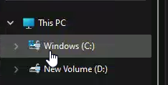
Double click on the C: Drive to display it’s contents
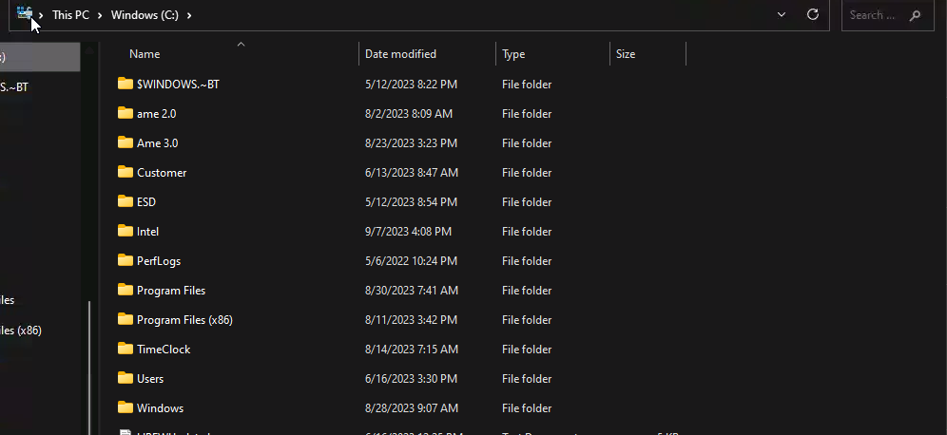
Click on the AME 3.0 file
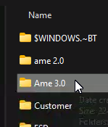
Once this folder is open we’ll navigate to the AME Config file
Right click on the AME Config file to pop out a menu that looks like this, We’ll be using the open with option to make the necessary changes.
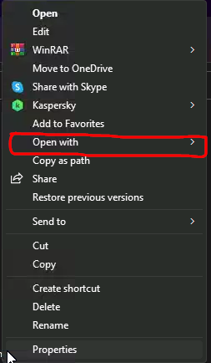
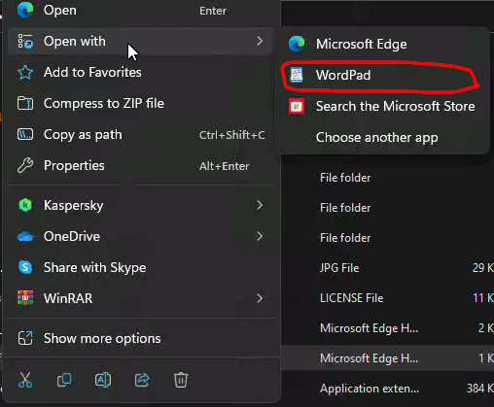
Once word pad is open, You’ll need to make these changes
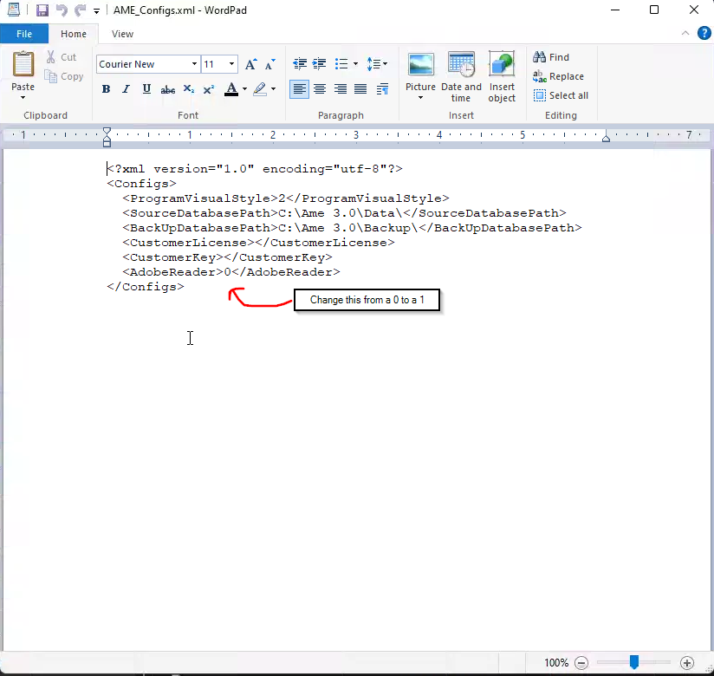
And now AME will open your documents in a PDF as intended.

