List Entries Walkthrough
In this Walkthrough we’ll go through how to use the list entries tab in PayRoll.
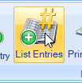
From the main menu, select your company, and click open
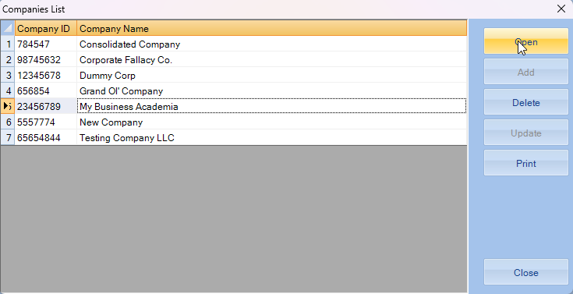
Now that we have a company selected we’ll click on the PayRoll Module
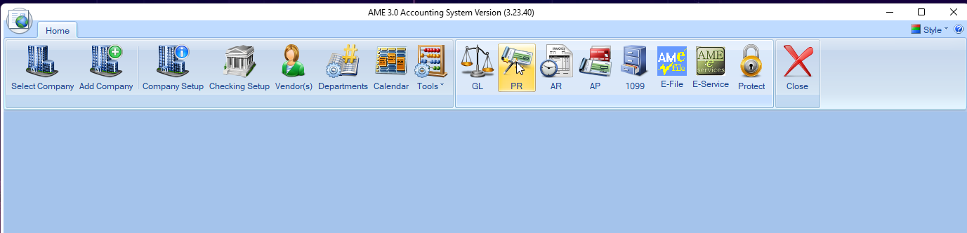
They Payroll module will open in a new window,
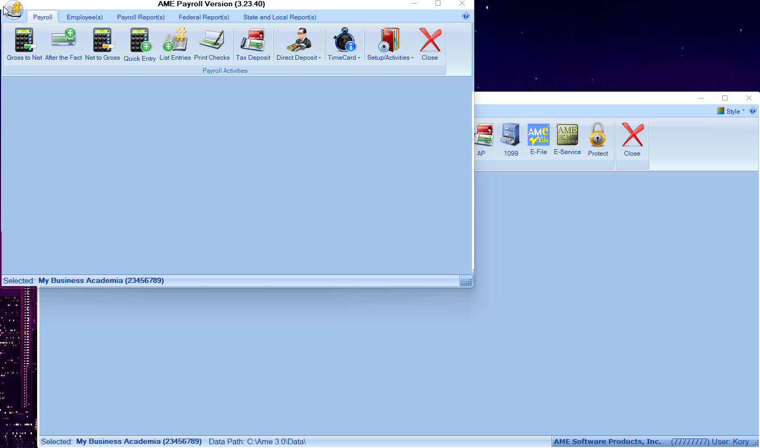

In the PayRoll window, we’ll click on the “List Entries” to bring up the box
