Employee Setup Walkthrough

Now that we have the company and banking set up, We’ll be going through the process to add employees to your company.

From the main menu, We’ll click on the Payroll icon:
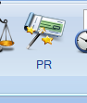

After clicking on Payroll, it will open in a new window with the PayRoll menu screen:
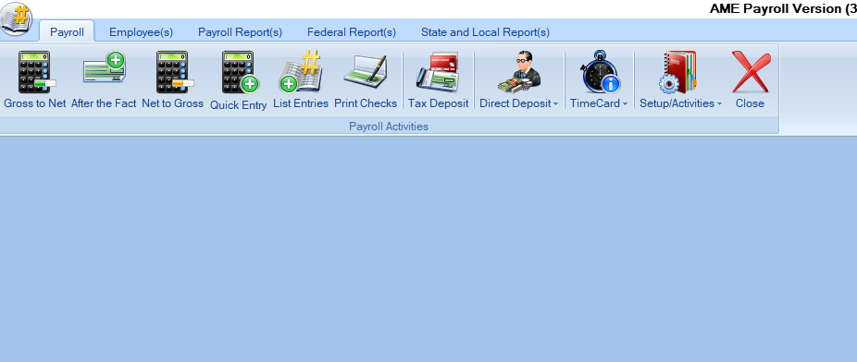
On this page, you’ll click on the Employees tab, to add a new employee:
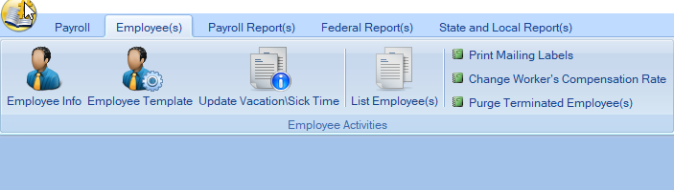
Click on Employee Info to add employees to your company:
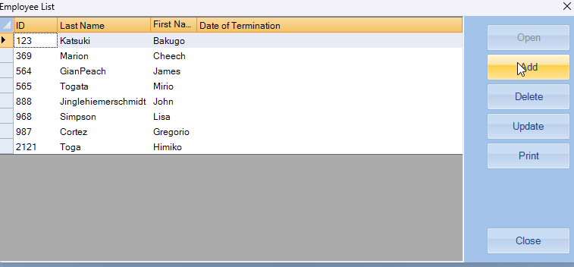

Click “Add” to start entering employee information, which will bring this box up
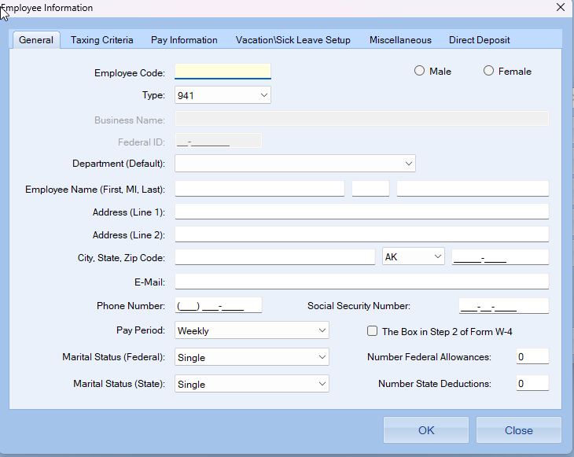

After filling out this information we’ll move on to the Taxing Criteria Tab:

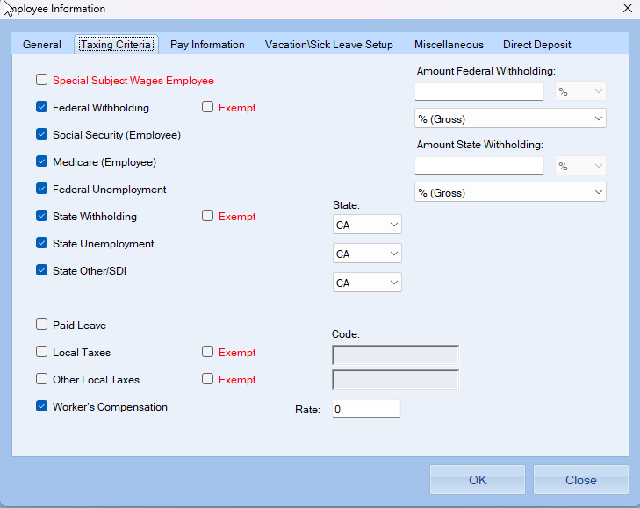

Once you’ve entered your tax values, it’s time to move on to Pay Information. TO add a line in Type of Pay, Pre-Tax Transaction, Or miscellaneous deductions right click on your mouse to pull up the add or delete options (see below)
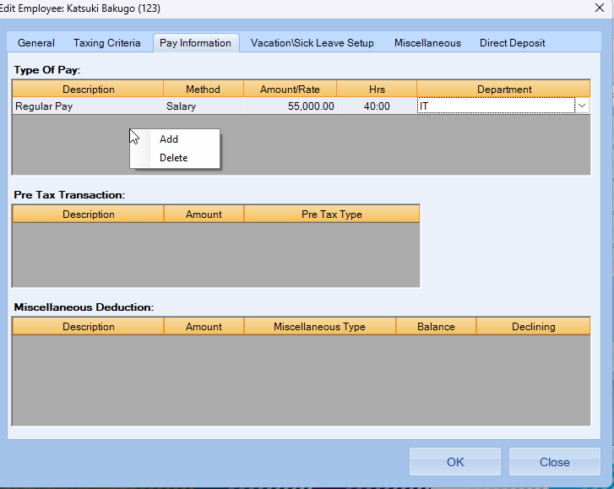

Once the pay information is complete, we’ll move on to Vacation and Sick Leave Setup. Here, you’ll be able to set the rates at which Vacation or Sick Leave are accrued:
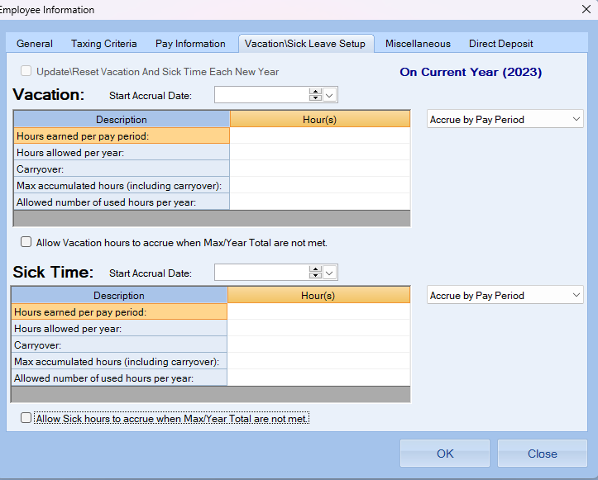

The next tab will be “Miscellaneous” which will include any other miscellaneous employee data like the hire and termination dates:
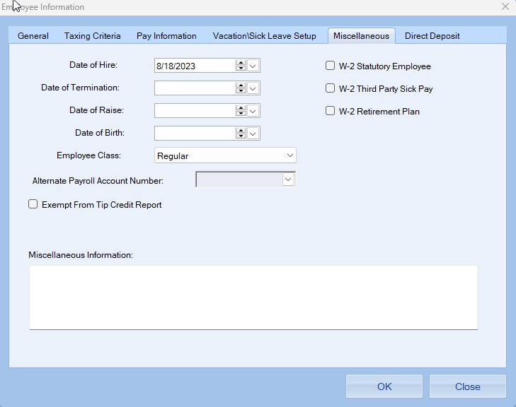

Lastly, The “Direct Deposit” Tab is to set up direct deposit for the employee:
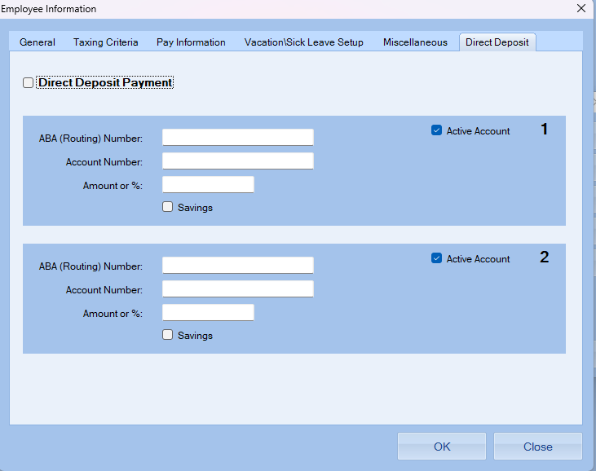

The employee template page is used to save basic information that can be used for multiple employees:
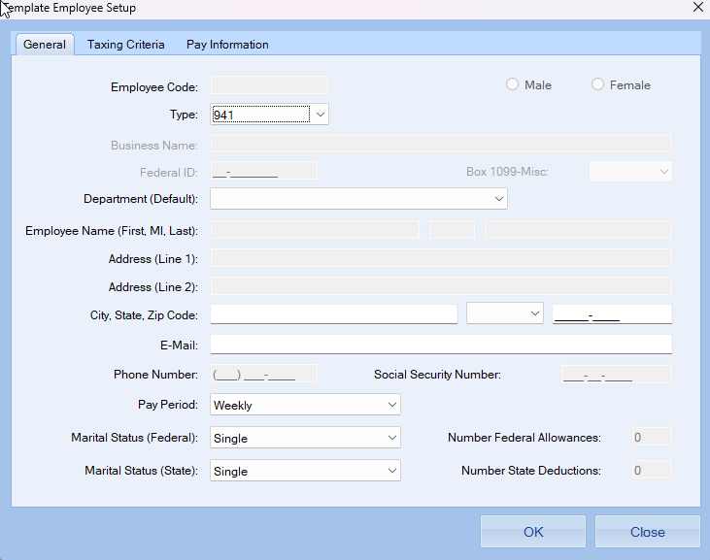
The Taxing Criteria tab is where you can input the tax regulations for the state
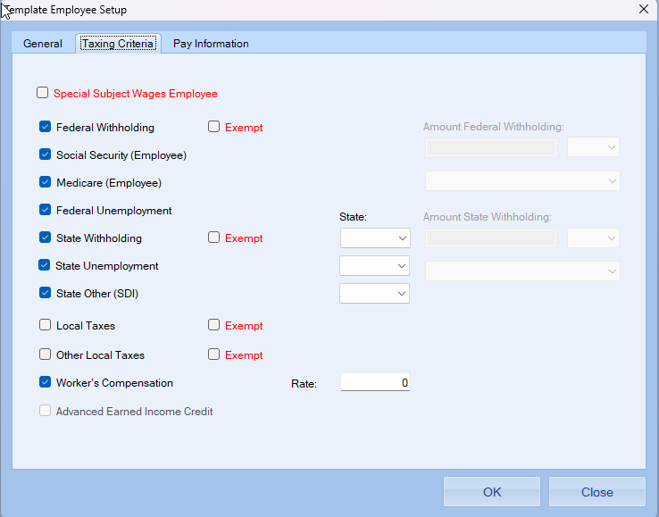

And the Pay Information Tab is for the types of pay for the different employees that you have,
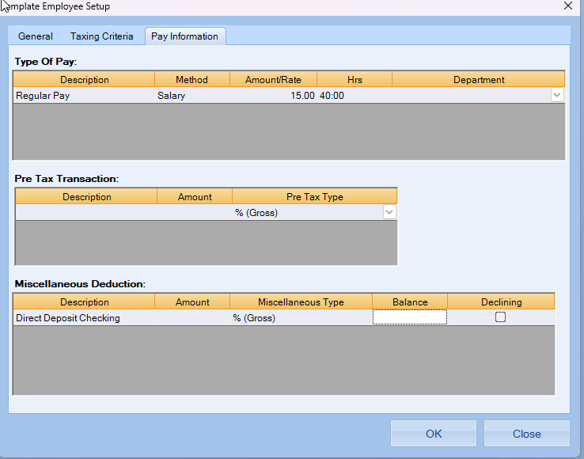

After inputting your information, click the OK button and now your employee is all set up!

