Difference in Tax Rate from 2.0
There is a difference in Tax rates for people who were hired before 2020 in the 3.0 program due to the fact that the dependants allowance was calculated differently.

IF the box “Employee has not submitted W-4 for 2020 was checked on an employee, then the tax rates will not match up in 3.0, here is how to change it.

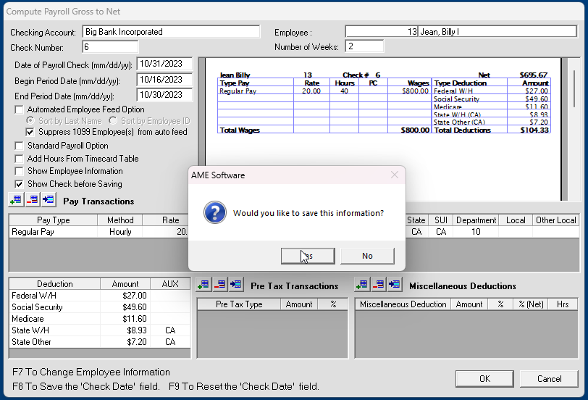(a)
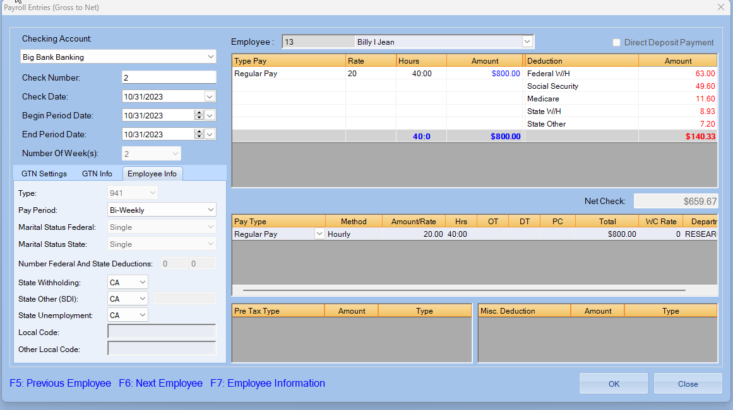
(b)
If you have calculated a payroll and notice that the tax rates are not matching up correctly… (seen above: (a)*2.0 version (b)*3.0 version)
Go to Employee Info
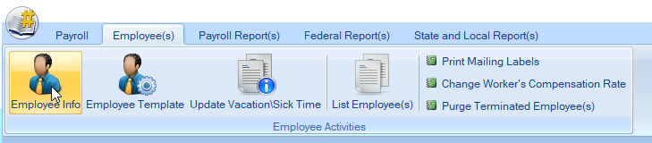
Which will open your Employee List
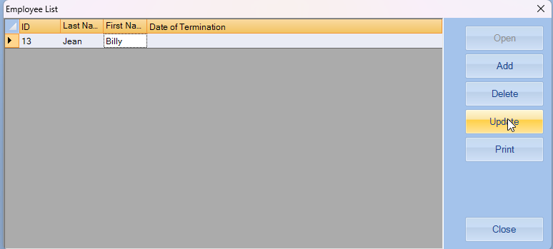
Click “Update” on the employee that is not being calculated correctly. Which will pull up the “Edit Employee” box
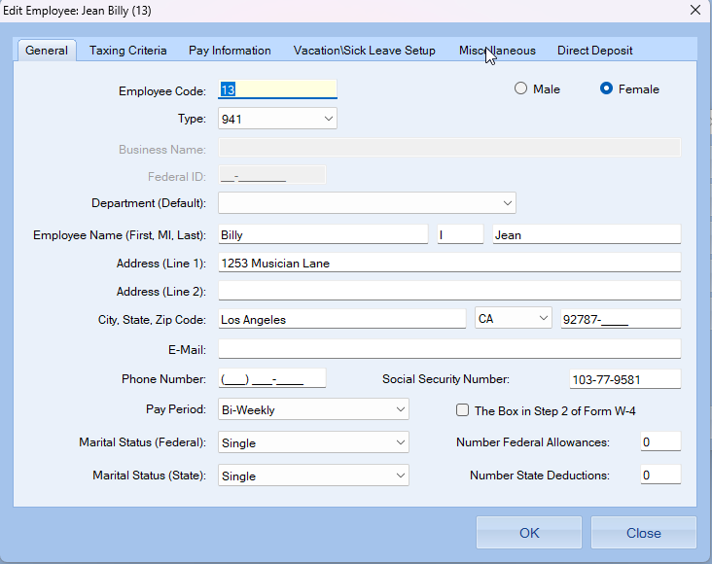
Click on the Miscellaneous tab to change the employee hire date.
(NOTE: HIRE DATE MUST BE SET AFTER January 1st, 2020)
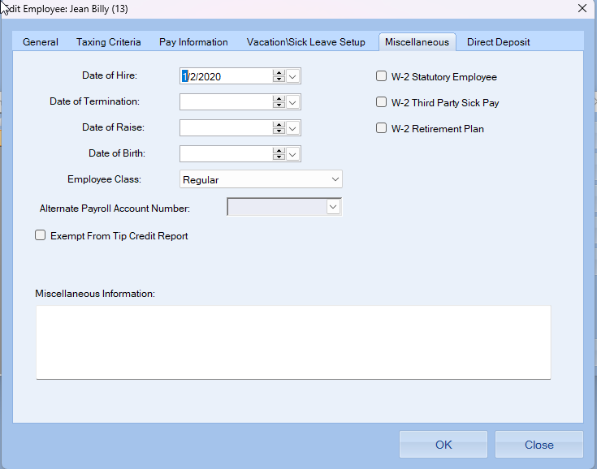
Now go back to create the payroll entry for that employee and the tax rate should be correct
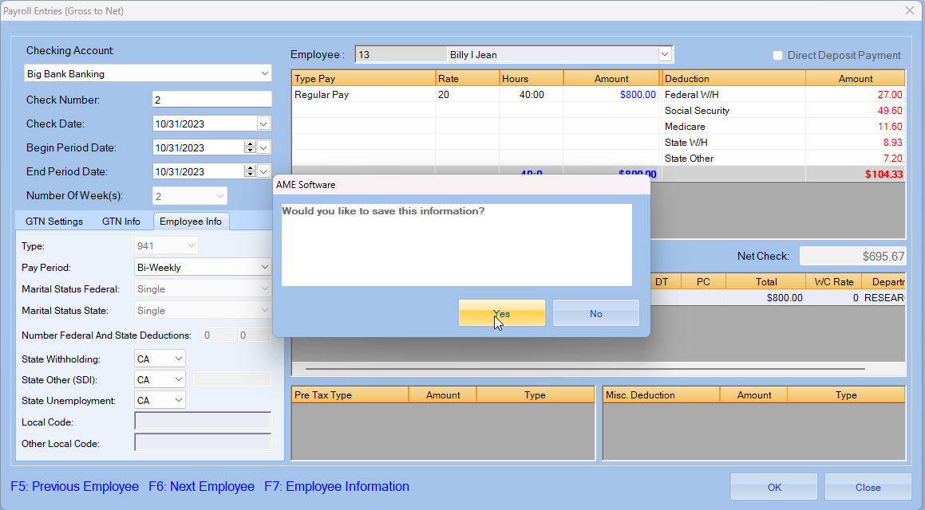(A)
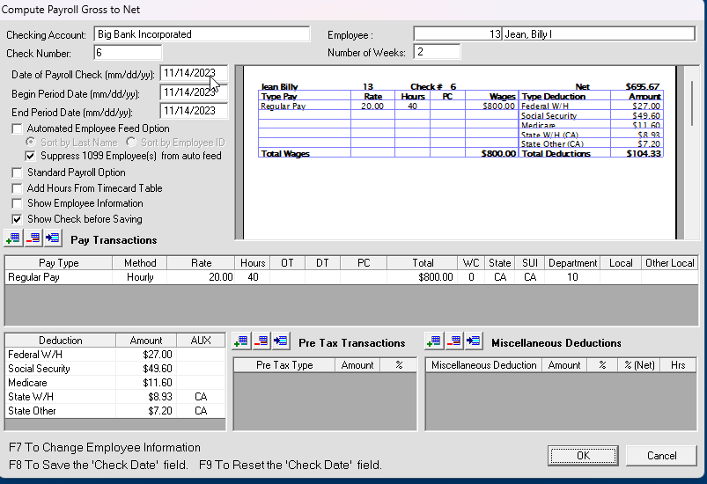(B)
(Seen above (A) 3.0 version AFTER change to hire date (B) 2.0 version

