Company Import Walkthrough
Now that you have 3.0 installed and registered, let’s import a company from AME 2.0…
From the main menu, Click on the Tools tab, Close to the bottom of the list you’ll see the “Import Company” option,
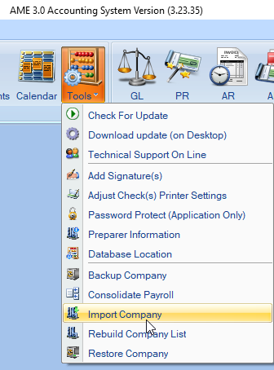

After clicking on Import you’ll be brought to a list of the companies listed in AME 2.0
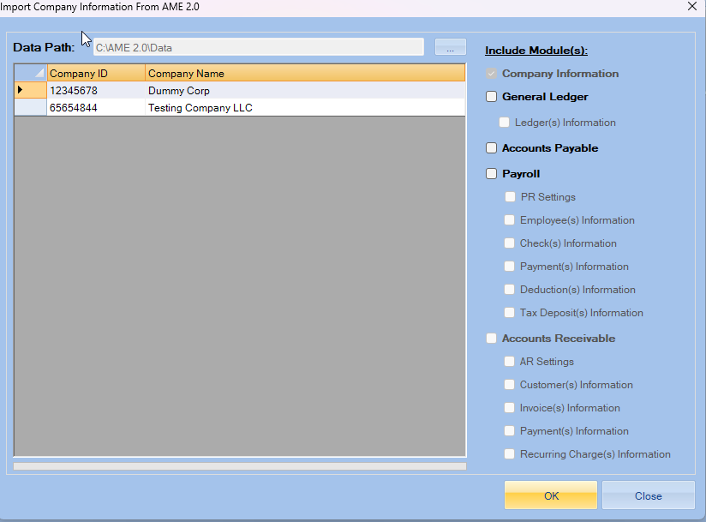
Click on the company you want to import so that it’s outlined/highlighted
(see below)
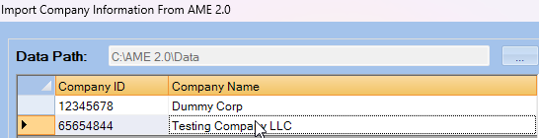

After the company has been selected, you’ll click on the module that you have active for the company (I.E. if you do Payroll AND General Ledger then you would click both boxes)
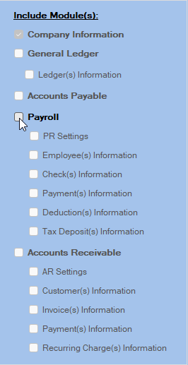
After you’ve selected the module, you have active, click the OK button.

At this point, you’ll see the boxes become check marked when the data has been transferred successfully.
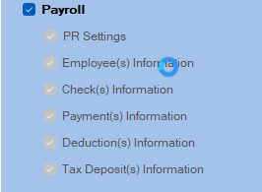
After the company information has been imported, A box will appear that shows you have successfully imported your data.
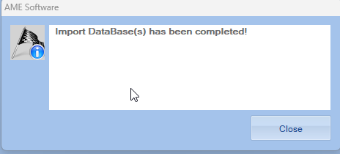
This Company is now available to work on in 3.0!

