Checking Setup Walkthrough
Now that you have your Company set up, let’s get the Checking information set up…
Starting on the main home page, click on “Checking Setup”:
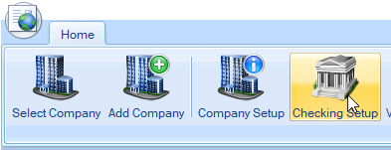

Which will open an empty box where you’ll add your bank information:
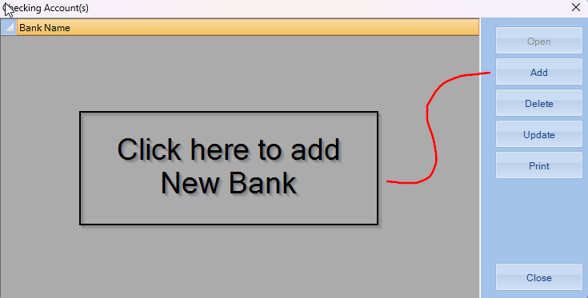

After clicking on Add, you’ll enter in all the information that will show up on your checks:
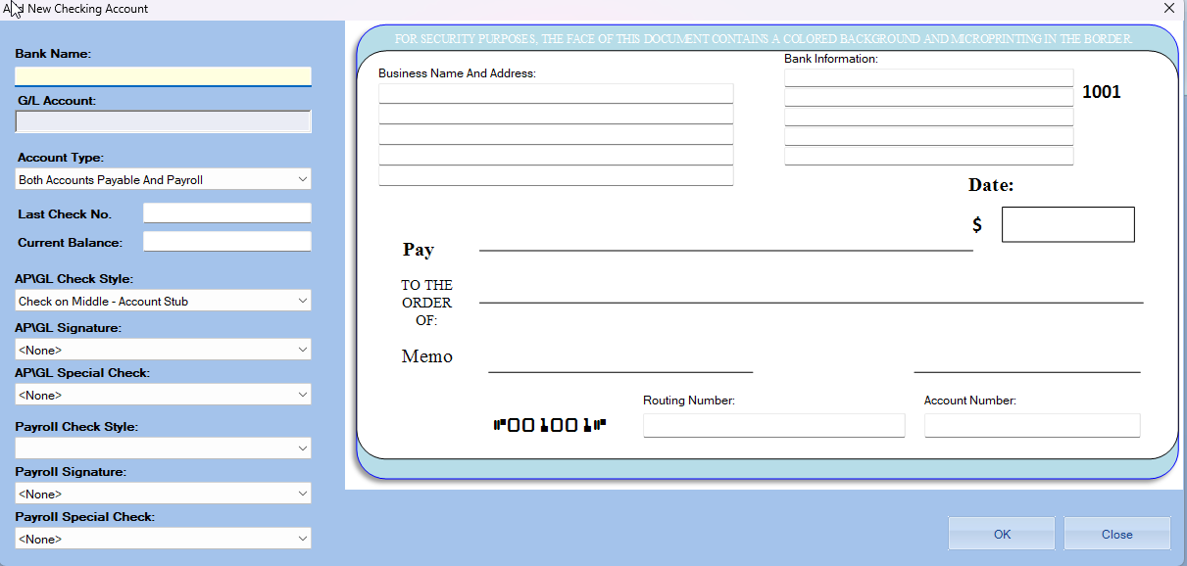
After filling out your information, your banking/checking is set to use!

