Payroll/Check Printing Walkthrough
For this tutorial we’ll go through the process of creating a check and then printing it.
Start out by choosing your company
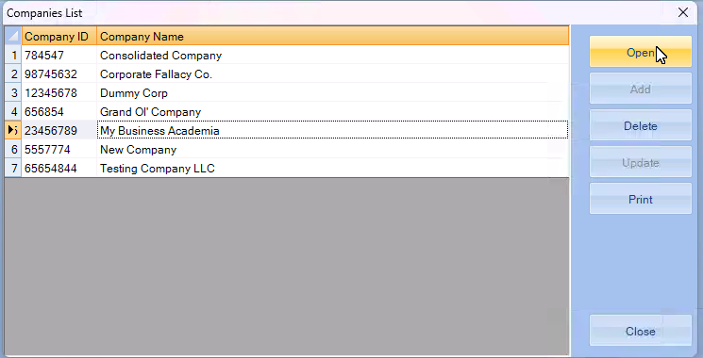
Go into PayRoll,
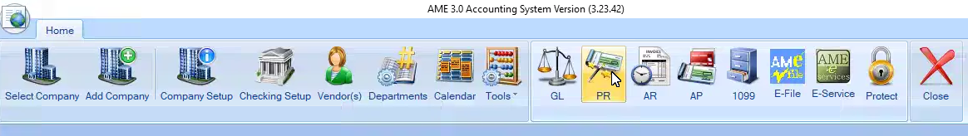
Which will open in a new window.
NOTE: Make sure that all your Tax Rates are set up!
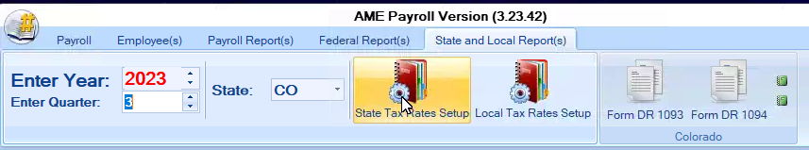
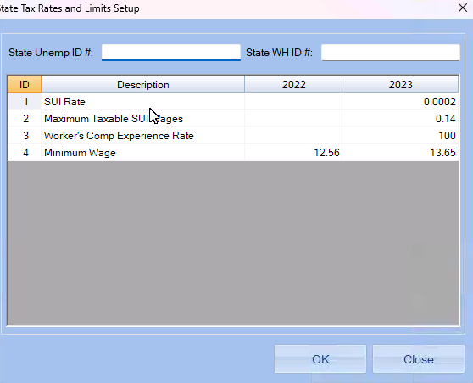
Once you ensure that your local and state tax rates are set up, we can move on to creating a check.
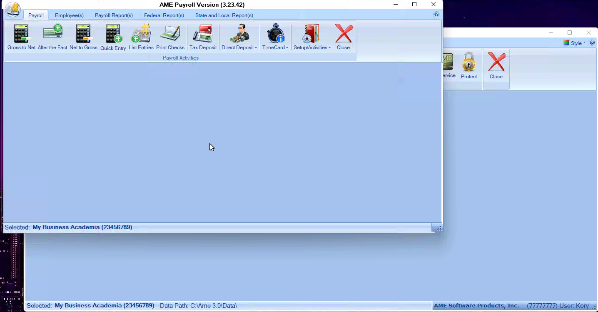

We’ll start by making a “GROSS TO NET” check. Click on Gross To Net
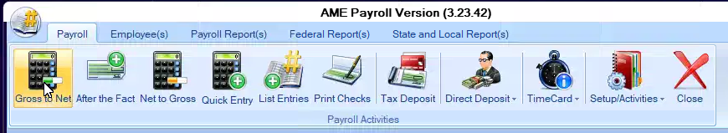
Which will open up this box:
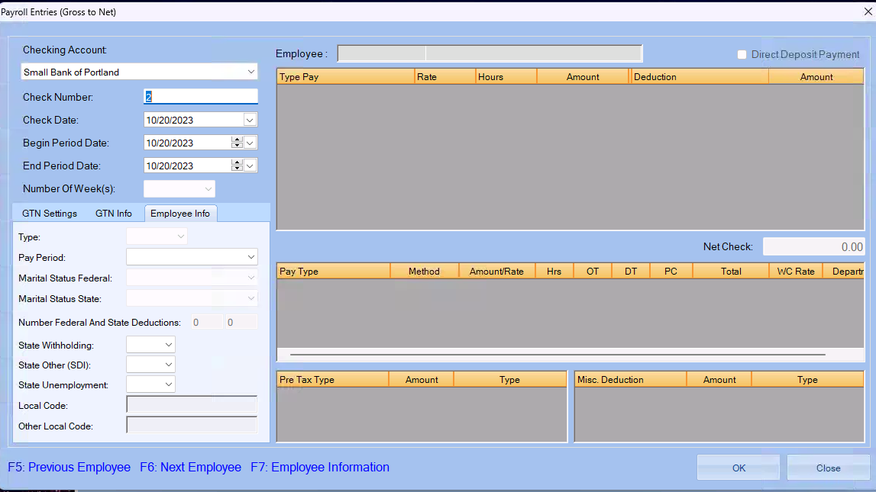
Choose your employee from the drop down menu
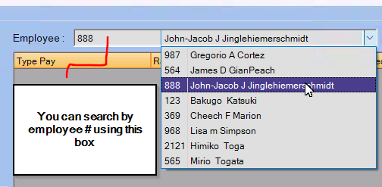
The employee pay type details will then populate if they have been filled out in the employee section.
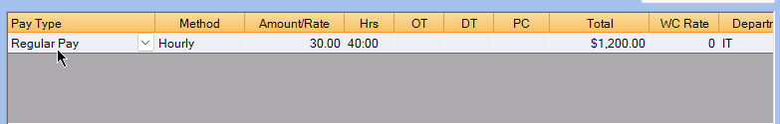
(See Employee set up below)
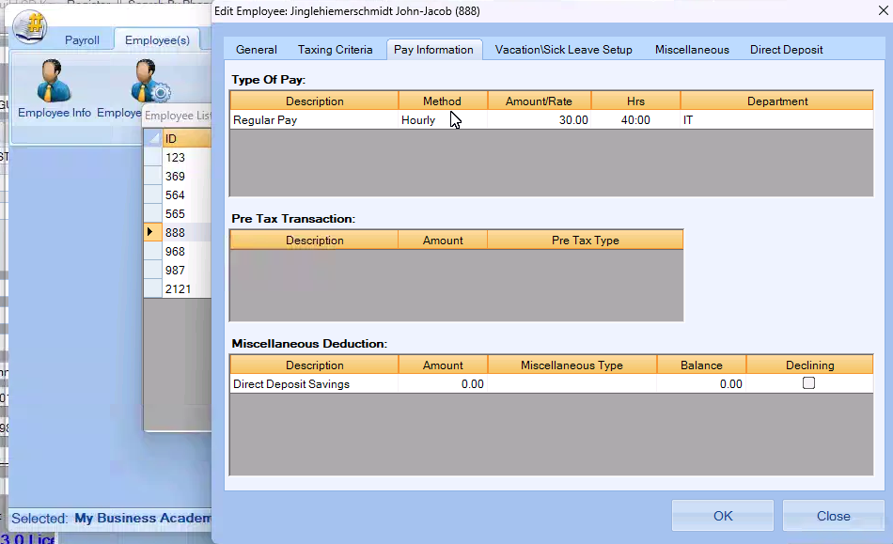
OR you can enter the information in manually by using the RIGHT CLICK in the grey area to add the pay type, pre-tax transactions, or miscellaneous deductions.
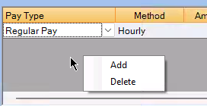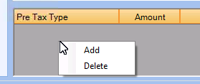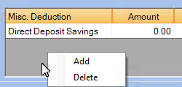
After you confirm that the information entered is correct, click OK to calculate the taxes on the payroll entry, It will ask if you would like to save this information
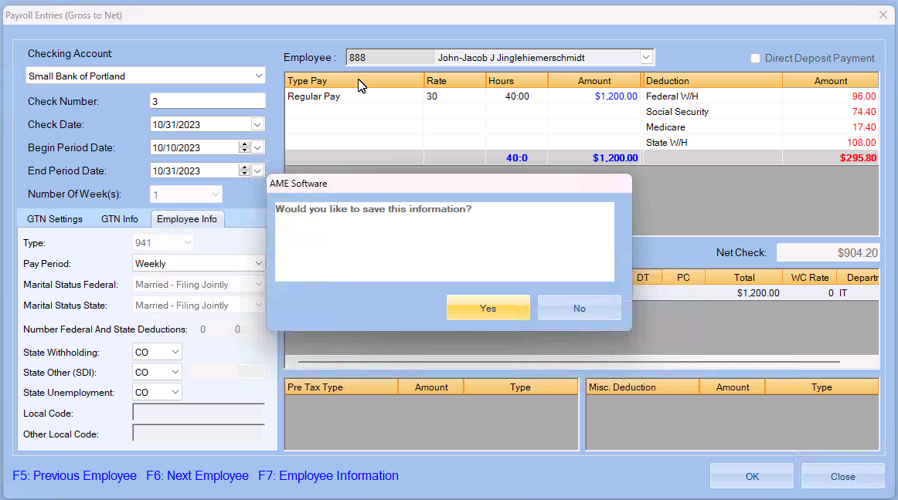
After clicking yes, you will have successfully created a Gross to net check.
Next, we’ll do an After the Fact check. After the fact are for checks that you have already issued and need record of.
Click on “After the Fact”
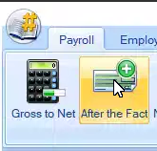

Which will open this box
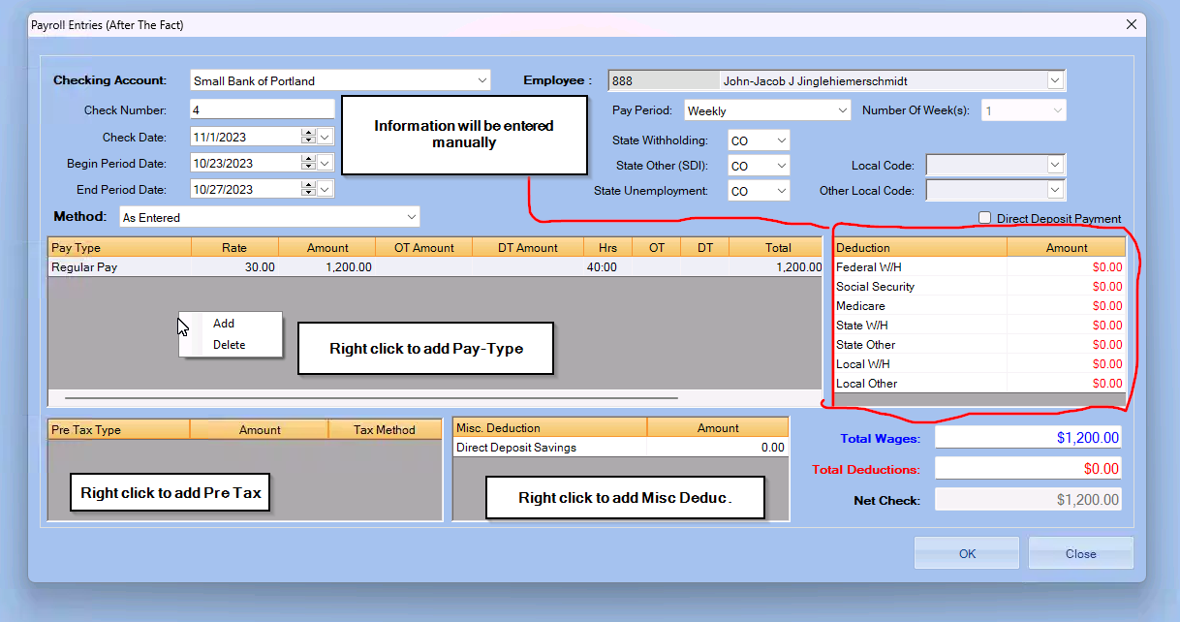
NOTE: FOR METHOD “Same as Previous check” ONE CHECK MUST BE SUBMITED “As Entered”
must be used at least once.
To use
After entering in all your information you’ll be asked to save the information
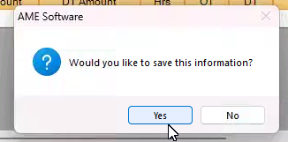
After that you’ve successfully created an After the fact check!

Now We’ll move on to Net to Gross. Net to Gross is used to find out the gross tax on a net dollar amount (i.e. $100 Holiday Bonus,etc.)
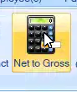
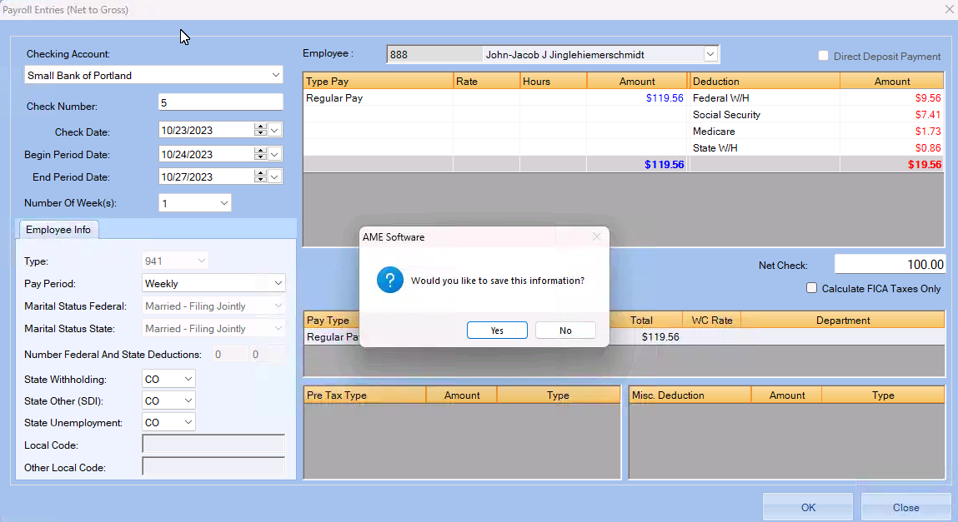
After entering the net dollar amount and clicking OK, the gross will calculate and you’ll be asked to save the information. After clicking “Yes” you’ll have successfully created a Net to Gross Check.

Now we’ll move on to Printing checks,
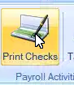

Click on Print Checks which will open this box
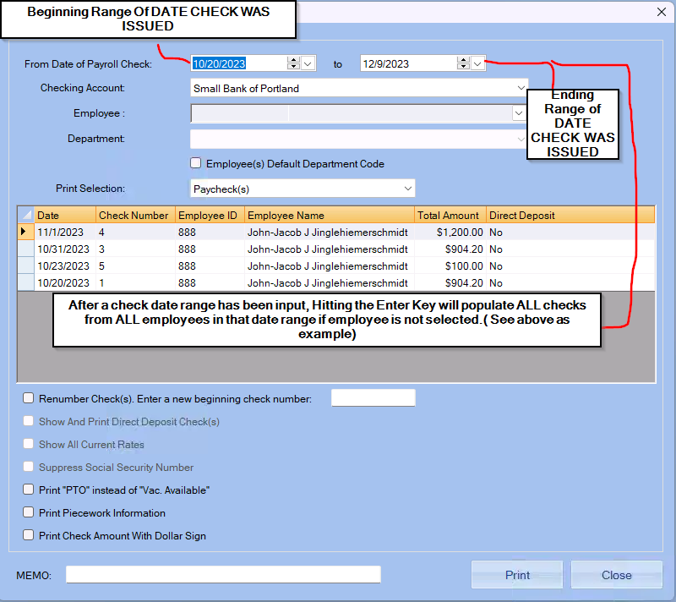
After confirming the checks, click Print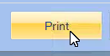
Which will then bring you to the Printing page of the checks
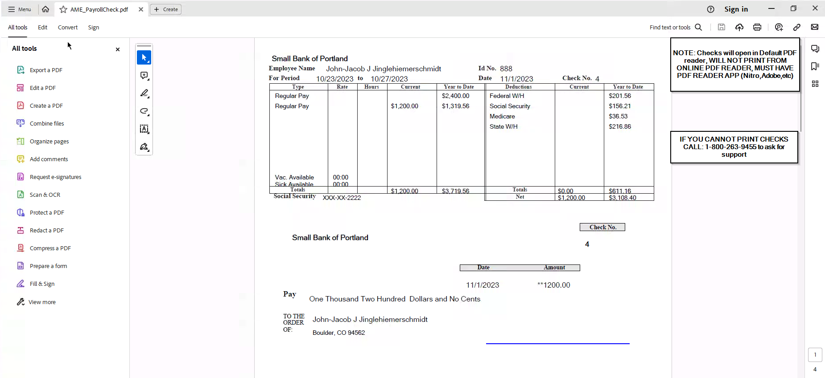
Choose the Printer that you want to print to, or choose “Print to PDF” to save the document as a PDF in the location of your choice.
And you’ve successfully gone from creating a check for your employee to printing a payroll check!

