Adobe Reader Download and Preferences
When setting up Adobe reader for the AME software these are the steps you’ll need to go through
First, visit the adobe website
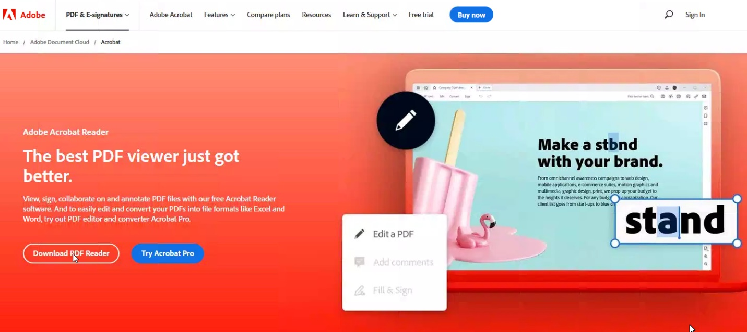
Adobe Reader is a free PDF reader program. Click on download to begin the process,
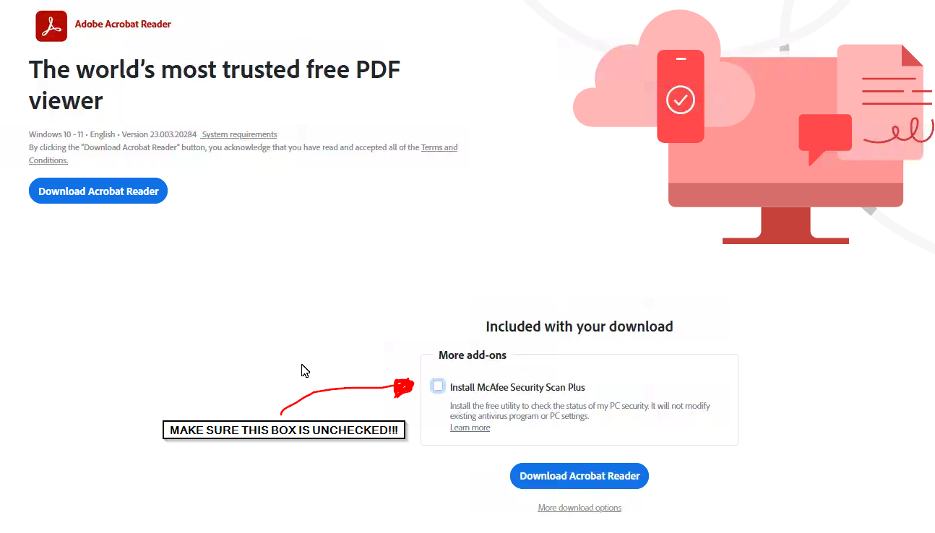
During the Adobe install, make sure to uncheck the McAfee add on bloatware.
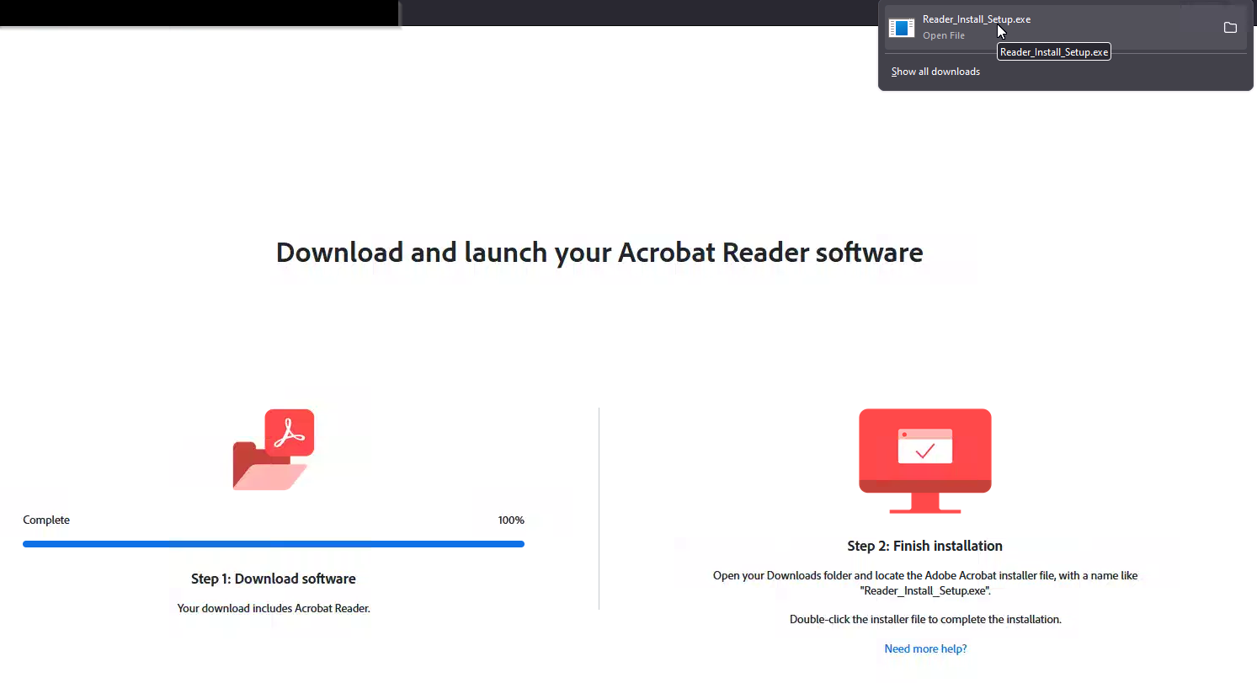
After downloading, click on the installer file in the top right corner Where there is an arrow facing down towards a line (Your downloads)
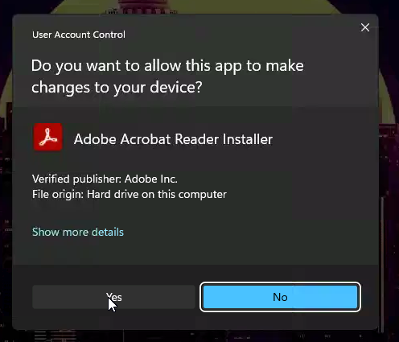
After the installation, you’ll land on the adobe reader dashboard page (seen below)
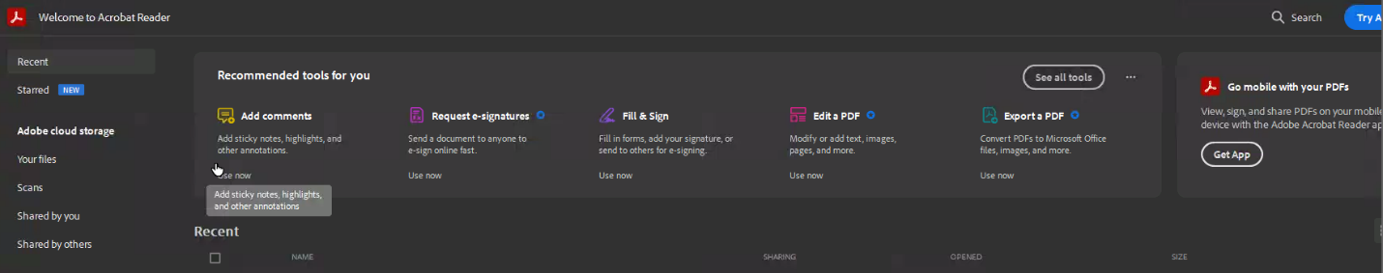
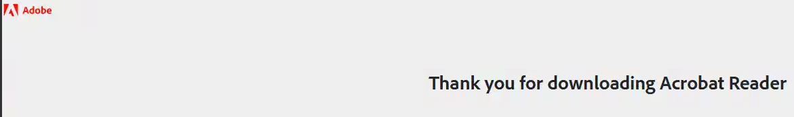
And now, we’ll need to get Adobe Reader set up for the AME software.
Go to the menu in the top left corner and navigate to “Preferences”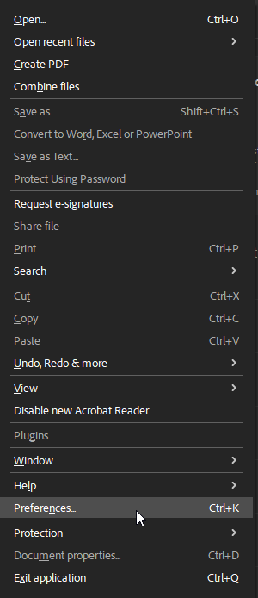
Once preferences is selected, you’ll navigate down to the “Enhanced Security” section.
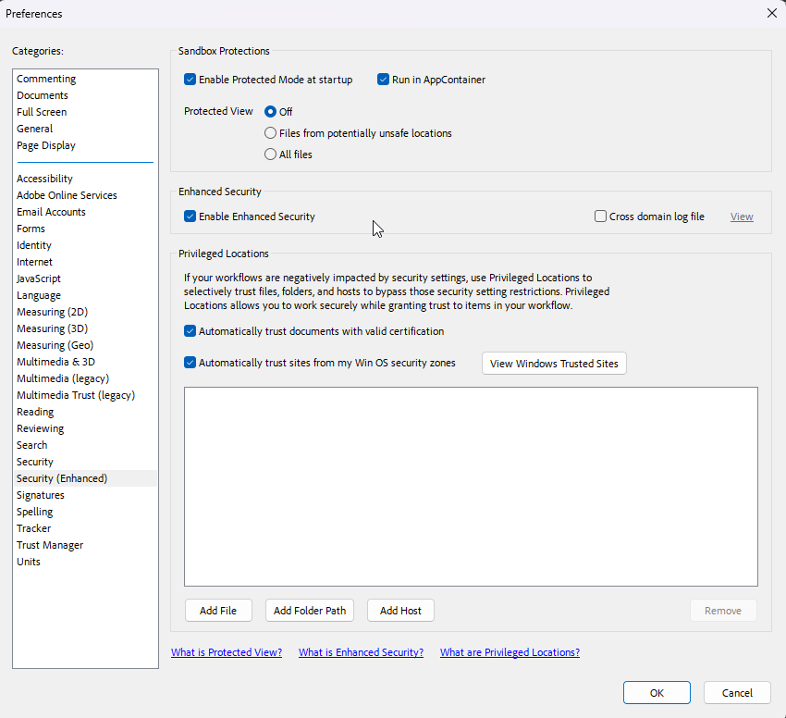
For compatibility with the AME software, you’ll need to uncheck:
- “Enable Protected Mode at startup
- Enable Enhanced Security
- Automatically Trust Documents with valid certification
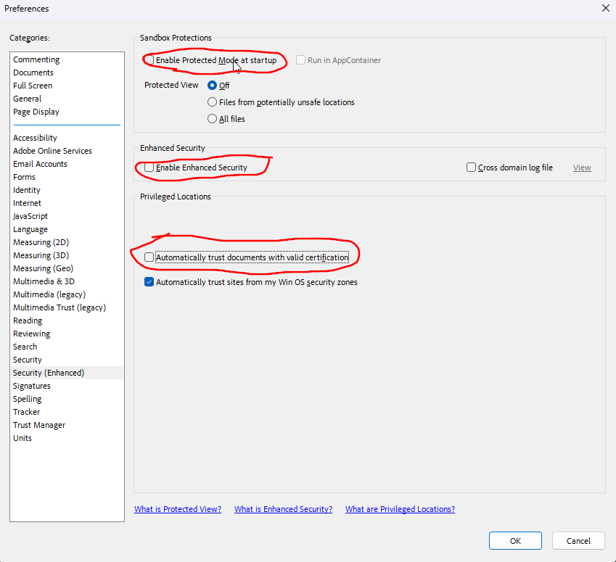
And now you should be good to go!

