Adding Signature to 3.0 Check
First you must scan signature or use one that you already Have.
If you are scanning a new one save as a PNG or JPG format.
Save anywhere on your computer in a file.
In 3.0 go to tools select add signatures.
Step 1. Click Add
Step 2. Select image in where you saved it
Step 3. Add Description click add again.
Step 4. Click ok file will be add to list.
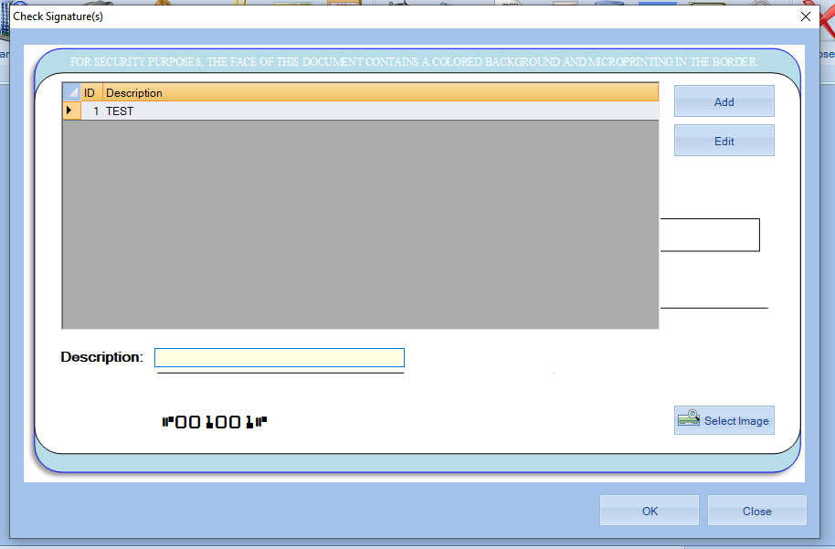
Step 5. go to checking setup open bank select Payroll Signature
Pick signature will show on signature line in window click ok your done.
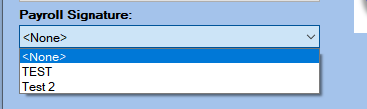
Go to payroll print check signature will be on check.

